**‘An Open Source 3D Printed Neuroprosthetic Powered by Induction Coupling’**

By

Humayun Gazi

An Honors report submitted for the Degree of:

BEng in Electrical and Electronic Engineering

**Synopsis**

Name: Humayun Gazi

Project: An open source 3D printed Neuroprosthetic powered by induction coupling.

Aim:

The aim of this project was to 3D print an open source prosthetic arm that capably utilizes an electromyographic sensor to identify muscle signals and convert it into electrical pulses to process movement and then modify it to allow for wireless power transfer through induction coupling. This was done by firstly, implementing electromyography in a prosthetic hand and then understanding the basis of wireless power transfer, testing its principles and then employing that information to design a system that would functionally apply to a Neuroprosthetic. Finally this system was implemented to exhibit an alpha design of what is possible in the neuroprosthetic field.

Testing:

* 3D print an open source prosthetic arm project and identify its capability through physical testing
* Study, identify and implement an electromyographic sensor to achieve a working Neuroprosthetic
* Assemble and code the electronic circuit
* Identify the working principles of induction coupling
* Design a receiver and transmitter coil for the onboard battery
* Calculate the coils internal resistance and inductance
* Simulate, test and implement an H-Bridge inverter for the transmitter
* Identify its AC output voltage
* Design and test a full wave bridge rectifier for the receiver
* Calculate the DC output voltage, rectification efficiency, peak inverse voltage, output frequency and quality Factor

Equipment:

The Experimentation took place in the Dubai Campus Electrical Lab. The Inverter Circuit, litz pancake coil and Diode Rectifier circuits were tested and produced in the lab. The following equipment was required to fulfill the needs of this project.

* Soldering Iron
* Breadboard
* Sinewave generator
* Voltage generator
* Oscilloscope

Procedure:

The general testing procedure had two parts. Firstly, identifying an open source schematic of a prosthetic hand, 3D printing and assembling it. Then attaching and testing an electromyographic sensor. Finally, ascertaining how it functions and why it’s essential to enhance the user experience. Secondly comes the power transmission circuits. The lithium ion battery located in the prosthetic charges at 500mA and 4.2 Volts. To safely charge this battery requires a constant currently flowing at a minimum of 5 Volts. Two circuits are required to achieve this; an inverter circuit that will convert a DC supply to AC voltage, transmit that wirelessly from a primary coil to a secondary coil and then rectify that incoming AC supply back to direct current in order to charge the battery. The following steps were then taken. A Schematic was utilized as reference for the transmitter circuit and the components required to build it were identified. A simulation was made on MATLAB to create the waveform of an H-bridge inverter circuit. This is the output that is wanted from the physical transmitter circuit. After recording the outputting waveform, the current and the peak to peak voltage produced, the coils were made with litz wire and tested to find their inductance and internal resistance. Further testing was made to see if the AC voltage was transferring enough power to the secondary coil. After checking the received voltage and current, a diode rectifier circuit was made so that constant 5V would be supplied to the charging module of the prosthetic, hence achieve induction coupling.

Problems Encountered:

Due to there being various ways to achieve wireless power transmission and a limiting factor being time, only induction coupling was tested and utilized. However this meant that various methods of induction coupling could be identified giving a more comprehensive approach as to why a specific model was chosen. Also a factor to consider was the limiting materials available at the time of 3D printing and the cost of electromyography technology, thus a very minimalistic design was chosen for the prosthetic in this dissertation.

Project Uses:

The purpose of this project is to establish a safer, faster, more convenient neuroprosthetic to those affected by amputation. This specific type of neuroprosthetic can be utilized for individuals suffering from amputation of the carpal bones of the wrist which contain the scaphoid, lunate, triquetral and pisiform proximal row. To demonstrate this, the idea was to create a cheaper, modular and easier to utilize prosthetic. To simply the life of the user, one could print a low cost prosthetic and then add functionality to it. The functionalities that are then implemented in this design are a neural connection and wireless charging. A further discussion as to why electromyography and wireless power transfer are impervious to this project will be seen in this report.

**Acknowledgement**

I would like to show my appreciation to Dr. Mutasim by offering my sincerest gratitude to him for the abundance of advice, theoretical and practical information he has given me that has enabled the completion of this dissertation.

**Statement of Authorship**



**Nomenclature**

A Cross sectional Area Square Meters

Ah Amp-hour Amps/Hour

$B$ Magnetic Field Tesla

C Capacitance Farads

$D_{1}$ Diameter of Strands Meters

E Energy Volts

EMG Electromyographic -

F Frequency Hertz

G Eddy Current Factor -

$H_{0}$ Complex RMS Value -

I Current Amps

KHz Kilo Hertz Hertz

K Proximity Factor -

l length Meters

L Inductance Henry

N Number of Turns -

$N_{B}$ Number of Bunching Operations -

$N_{s}$ Number of Individual Strands -

$N_{C}$ Number of Cabling Operations -

P Power Watts

$P_{j}$ Internal Reactive Power

PLA Polylactic Acid -

PE Potential Energy Volts

Q Quality Factor -

Q Charge Amps

R Resistance Ohms

Rac Resistance to AC Current Ohms

Rdc Resistance to DC Current Ohms

STL Standard Tessellation Language -

T Time Period Seconds

$μ_{o}$ Permeability of free space Farads/Meter

$μ_{r}$ Permeability of Iron Core Farads/Meter

V Voltage Volts

Vdc DC Voltage Volts

Vac AC Voltage Volts

Vmax Maximum Voltage Volts

Vrms Root Mean Squared Voltage Volts

Vripple Ripple Voltage Volts

$ω$ Angular Frequency Hertz

XL Inductive Reactance Ohms

$Φ$ Magnetic flux Weber

$∆$ Change in Time Seconds

$δ$ Skin Depth -

$σ$ Conductivity Siemens/Meter

**Index**

Chapter 1: Introduction 1

1.1 Aim and Objectives 1

1.2 Project Description 2

1.2 Project Planning and Management 4

1.4 Project Applications 5

Chapter 2: Background Information 6

2.1 Literature Review 6

2.2 Background Theory 10

2.2.1 Electromyography in Prosthetics 11

2.2.2 EMG 11

2.2.3 Electrical Potential 11

2.2.4 Battery Management 12

2.2.5 Battery Technical Information 13

2.2.6 Lithium Ion Batteries 15

2.2.6.1 Working Mechanics of a Li-Ion Cell 15

2.2.6.2 Lithium Ion Battery Limitations 15

2.2.7 Faradays Law 16

2.2.8 Transformer Theory 16

2.2.9 Resonance Frequency 18

2.2.10 Coil 18

2.2.10.1 Skin Effect 19

2.2.10.2 Maxwell’s Equation 19

2.2.10.3 Proximity Effect 20

2.2.11 Rectification Theory 21

Chapter 3: Procedure 23

3.1 Prosthesis Build Process 23

3.1.1 PLA Material 23

3.1.1 Arduino Nano Board 24

3.1.2 Servo Motor 25

3.1.3 MyoWare EMG Sensor 26

3.1.4 Lithium-Ion Battery Management Circuit 28

3.1.5 Boost Board 31

3.1.5 Assembly 32

3.2 Induction Coupling Build Process 32

3.2.1 H-Bridge Inverter Circuit 32

3.2.1.1 IRLZ44N MOSFET 35

3.2.1.2 IR2113 MOSFET Driver ICs 35

3.2.1.3 NE555N Timer IC 36

3.2.1.4 74HC4049N inverting IC 36

3.2.1.5 H-Bridge Inverter Assembly Process 36

3.2.2 Litz Coils 37

3.2.3 Full Wave Bridge Rectifier Circuit 38

Chapter 4: Tests Results and Analysis 41

4.1 Results Layout 41

4.1.1 Mechanical Prosthetic Simulation 41

4.1.1.1 Strength Simulation 41

4.1.2.1 EMG Sensor Threshold Verification in Arduino IDE 43

4.1.2.2 EMG Sensor Physical Simulation 43

4.1.2.3 Prosthetic Physical Simulation 44

4.1.2 Transmitter and Receiver Coil Calculations and Results 45

4.1.3 H-Bridge Inverter Simulation 48

4.1.4 Full Wave Bridge Rectifier Results 51

Chapter 5: Conclusion 55

5.1 Final Project Results 55

5.2 Project Limitations and Problems 55

5.3 Future Work of the Project 57

5.4 Project Uses 57

Chapter 6: Sources of Information 59

6.1 References 59

6.2 Bibliographies 61

Appendix A: Minute of Meetings 62

Appendix B: Project Timetable 73

Appendix C: Fourier Transform of Full Wave Bridge Rectifier 75

Appendix D: Schematic, Simulation and Fourier analysis for H-Bridge Inverter Circuit 78

Appendix E: Arduino IDE Code for Prosthetic 83

**List of Figure and Tables:**

**Figure 1. Complete 3D Printout of Prosthetic** 24

**Figure 2. Nano Board Pin Layout (Arduino AG, 2017)** 25

**Figure 3. Inside a Servo Motor (Eglowstein, H., n.d.)** 25

**Figure 4. MyoWare Process of Conversion (Mayo Clinic, 2017)** 26

**Figure 5. MyoWare Microcontroller Setup (Mayo Clinic, 2017)** 27

**Figure 6. Li-Ion Charging Profile (Battery University, 2016)** 29

**Figure 7. TP4056 Charging Module Diagram** 30

**Figure 8. Complete Charging Cycle of TP4056** 30

**Figure 9. XL6009 DC-DC Boost Converter** 31

**Figure 10. H-Bridge Configuration (Modular Circuits, n.d.)** 33

**Figure 11. H-Bridge Ideal Square Wave Output (Harish et. al., n.d.)** 34

**Figure 12. Coil Quality vs. Frequency Graph** 38

**Figure 13. Full Wave Bridge Rectification Circuit (Agarwal, T., n.d.)** 39

**Figure 14. Pulsating DC Signal of Diode Bridge Circuit (Agarwal, T., n.d.)** 39

**Figure 15. Statistical Analysis of Forces on a Biological Finger (Hu et. al., 2014)** 42

**Figure 16. Serial Data from the MyoWare Sensor** 43

**Figure 17. Neuroprosthetic Mimicking Hand Function** 44

**Figure 18. Litz Wire Pancake Coil Specification** 48

**Figure 19. 555 Timer PWM Output** 49

**Figure 20. Breadboard Testing of H-Bridge Inverter** 49

**Figure 21. H-Bridge Output Waveform** 50

**Figure 22. Diode Bridge Frequency Comparison** 53

**Table 1. Cost of Components** 4

**Table 2. H-Bridge Inverter Truth Table (Modular Circuits, n.d.)** 34

## Chapter 1: Introduction

In the biomedical field, the study and implementation of energy aware integrated circuits and hardware for an ultra-low power approach to cognitive neural prosthetics is a concept that is explored extensively. A neuroprosthetic is a brain-computer interface which allows a device to replace a missing biological function, as in physical, visual, auditory, motor, sensory and cognitive roles in the human body. Since a prosthetics primary goal is to ease the daily functions of its user, other factors possibly deterring this must be considered. These can include complications in physically attaching a prosthetic, human error or negligence when in contact with electrical components, ease of use, and possible surgical infections. Therefore a simple yet intricate solution to these problems is wireless commination and power transmission as this limits human contact. It is proposed that, as is seen being employed more frequently in the Neuroprosthetic field, the use of an electromyography sensor be implemented as it can convert muscle signals into electrical pulses thus requiring minimal to no surgeries for those that are affected by amputations of some kind. Further taking this concept, using induction coupling to wirelessly power the on board battery, would enhance the users experience whilst increasing functionality. A practical alpha model was created to test the properties of electromyographic technology and induction coupling to show that implementing it on a prosthetic arm does increase the functionality of its user.

### Aim and Objectives

The aim of this project is -

* Develop an understanding of Neurology and it current medical applications for the handicapped
* 3D print an open source prosthetic arm project and identify its capability through physical testing
* Study, identify and implement an electromyographic sensor to achieve a working Neuroprosthetic
* Simulate stress analysis on a compiled Standard Tessellation Language (STL) file
* Identify the working principles of induction coupling
* Design a receiver and transmitter coil for the onboard battery
* Calculate the coils internal resistance and inductance
* Simulate, test and implement an H-Bridge inverter for the transmitter
* Identify its AC output voltage and power rating
* Design and test a full wave bridge rectifier for the receiver
* Calculate the DC output voltage, rectification efficiency, peak inverse voltage, output frequency and quality Factor
* Demonstrate a cohesive functional neuroprosthetic prototype of a hand

### 1.2 Project Description

To begin this project, the initial step taken was researching all the relevant materials required. This included an in depth analysis and review of Neurology, battery management, DC to AC transformation, diode rectifier and coil theory. This helped generalize an idea on how to move forward with the project as well as the conclusions that may be formed during it.

What was initially determined is that a neuroprosthetic replicates the function of the limb it is replacing. Its replication can occur because it is capable of reading the muscle signals left at the point of amputation. These signals still function as the human mind is still capable of ‘feeling’ what it is missing. This is called phantom limb. In order to read these muscle signals, electromyography is used. Electromyography is an electro diagnostic technique that records electrical activity that lingers from a muscle tissue. Therefore, an Electromyographic (EMG) sensor will read the information at the point of amputation and send it to a controlling device that can implement the information it receives to perform an action. This thus allows one who is amputated to drive information through the muscle tissue to a device, or prosthetic, that will read it, understand and then utilize it to do what the user wants. This provides a plan of action that will give results that are conclusive to this report. Therefore, a design for a prosthetic is required that will allow for the implementation of EMG sensors.

What was further understood by studying the connection between biology, neurology and Orthology of a human anatomy is that there are still biological hazards and pitfalls that can occur at the point of amputation years after a procedure. These biological hazards include parasites and infections that may potential lead to unwanted results. What was also understood is that the point of neuroscience and its biomedical engineering application is to ease the life of its users. Therefore it is necessary to implement newer technologies wherever it is applicable. The idea then becomes how will the application of newer technologies simplify yet further functionalize a working prosthetic. This lead to the application of wireless power transmission. Limiting contact to the prosthetic leads to fewer biological infections, thus decreasing the potential of unwanted results; therefore adding functionality to a prosthesis. This establishes an idea of what materials are required, what tests need to be taken and how to design the circuits to perform the tasks at hand.

Initial testing provided data such as material used for print, materials required for assembly, the maximum strength of the motors utilized, the required microcontroller, and a simulated strength analysis of the combined prosthetic. Once the neuroprosthetic was assembled, four tasks needed to be completed; attaching and testing the electromyographic sensor, calculating and designing the transmission and receiver coils, implementing and testing an H-bridge inverter circuit that converts DC to AC for wireless power transmission through the coils and finally rectifying the incoming power with a full bridge wave rectifying circuit allowing for constant DC voltage to sufficiently charge the on board battery of the prosthetic.

An assessment of each component required to assemble this project was made. A clear discussion of the simulations, testing and assembly of each component was established. Furthermore, an analysis of the data was conducted to realize a final working proof of concept.

### Project Planning and Management

During the course of any project, time allocation and management is of most importance. This gives a time frame to gather and understand any necessary information, plan the tests that need to be conducted and implement a functioning design. Through this a working finalized project will be completed.

Throughout the course of this dissertation project, multiple project meetings were arranged with the project supervisor, Dr. Nour Mutasim. These meetings were a tool to allow for a constant progression of the project. Key aspects were discussed that allowed the project supervisor to give valuable advice and feedback in order to steer this project to its inevitable conclusion. Minutes of these meetings were taken and can be seen in Appendix A.

Also, a timeline was made to allow for better time management. This included hurdles that needed to be crossed and milestones that had to be reached to achieve succession. Additionally, a logbook was kept to record valuable information, such as dates and times for conducted experiments, personal deadlines and achievements.

As a physical project was manifested costs to build it have occurred as shown in table 1.

**Table 1. Cost of Components**

|  |  |
| --- | --- |
| **Components** | **Cost** |
| 3D Printing of the Prosthetic | 780 AED |
| MyoWare Muscle Sensor | 189 AED |
| MyoWare Electrodes | 45 AED |
| TP4056 Module | 45 AED |
| IR2113 Gate Driver IC | 23 AED |
| Components for Circuits | 110 AED |
| Litz Coil | 130 AED |

Therefore the total cost of the project is 1322AED.

### 1.4 Project Applications

The point of this project is to provide a proof of concept to establish a safer, faster, more convenient prosthetic to those affected by amputation. This concept is adding functionality to a prosthetic to do two things. Firstly, utilize an electromyographic sensor to enable an amputee to use the prosthetic with relative ease. This sensor will create a neural pathway that allows an amputee to think of an action and reproduce that with a prosthetic. The second function is wireless power transmission. Wireless power transmission is added to the prosthetic by using induction coupling techniques. This increases the functionality of the prosthetic as it allows the amputee to easily charge it for use whenever needed whilst minimize unnecessary contact with the point of amputation, reducing the risk of infection. Therefore this project will identify how to utilize EMG sensors and induction coupling with a prosthetic hand for those that are physically handicapped.

## Chapter 2: Background Information

In this section of the report all the necessary information and background theory pertaining to the research and development of low cost multifunctional modular Neuroprosthetics and power transmission schematics will take place. A literary review displaying extensive publications that expand on all the various parts that come together to form a cohesive working prosthetic will take place. Evidence will be supported. Ideas will be discussed. Data will be backed up with factual evidence from various studies and cases ranging from medical to electrical to monetary requirements. In the end a concept will be proven.

### 2.1 Literature Review

To first understand the necessary steps to producing a working neuroprosthetic that can imitate the functions of a hand, one must understand the history, types and implementation of Neuroprosthetics currently in development. In the article “Neuroprosthetics in Amputee and Brain Injury Rehabilitation” (Eapen et al., 2016), it is stated that the purpose of rehabilitation programs is to recover one’s quality of natural life. Those that are affected by amputations would see an improvement of quality in their everyday lives by mimicking the functions that they have lost. This is achieved by using a prosthetic. This sentiment is echoed in “A Reconfigurable Hebbian Eigenfilter for Neurophysiological Spike Train Analysis” by Yu et al., who elaborates on the definition of a neural prosthetics by stating that it is a brain machine interface that helps improve the quality of life by restoring cognitive and neural functions to individuals that are suffering due to disability or injury. Eapen et al., further goes on to state that a neuroprosthetic augments a motor, sensory or cognitive communicative function by tapping into spared brain and spinal circuits. Supposedly then, those that are affected by amputations would have neural connections, such as nerve endings, that can be stimulated to perform functions, preferably the ones that were lost.

Manuel F. Casanova states in the article, “Canonical circuits of the cerebral cortex as enablers of Neuroprosthetics”, that the use of Neuroprosthetics is largely predicated on the existence of generic circuits which can be artificially stimulated. These generic circuits carry operations within the cerebral cortex where within are contained the vertically oriented cellular elements that conjointly act as a circuit, as is well documented within the field of neuroanatomy, most notably by Lorente de No. No further states that the elementary unit within the cerebral cortex may theoretically allow the transmission of impulses from the afferent fiber to the efferent axon (Casanova, 2016). Thus the connection between the mind and an object is conceivable. Grahn et al., states in the article “Restoration of motor function following spinal cord injury via optimal control of intra-spinal microstimulation: toward a next generation closed-loop neural prosthetic”, that movement is synchronized by the mind and performed by contracting muscles situated on a specific joint. The motor instructions are instigated in the brain and then travel through neural pathways in the spinal cord to the motor neurons before performing an action. If injury were to occur and paralysis or amputation has become a reality, the planning center of the brain, its peripheral nerves and muscles remain functional. Grahn et al., goes on to say that motor function can possibly be restored by directing electrical stimulation of the neuromuscular system through the use of a Neuroprosthetic. These Neuroprosthetics, especially upper body prosthetics are either body powered or myoelectric systems. Myoelectric systems can allow the patient to control the hand, wrist and the elbow (Resnik et al., 2014, cited in Eapen et al., 2016). These systems convert muscle signals into electrical pulses that allow for the mind prosthetic connection. Its first discovery was by an Italian scientist and physician Luigi Galvani who learnt that muscle and nerve are electrically excitable. It was found that the strength of stimulation varies significantly with variances in frequency, amplitude and pulse width of the stimuli. Myoelectric sensors are a form of transcutaneous stimulation which relies on the use of electrodes placed on the skin directly over a muscle motor point making it extremely affordable, non-invasive and reversible. This makes it a much simpler approach to other forms of neural prosthetics such as percutaneous stimulation, implanted intramuscular and peripheral nerve stimulation and Intra-spinal microstimulation (Grahn et al., 2014).

A brain machine interface such as the myoelectric system used in a neuroprosthetic is simply a neural interface system that records analyze and decodes the brain signals. Though it provides a simple noninvasive recording technique, problems due occur. Firstly, it has been proven extremely difficult to control multiple degrees of freedom due to challenges extracting and decoding individual signals as well as inherently low spatial resolutions. Also electrode migration, immune responses of the body and disruption of surrounding neural tissue at the point of amputation, limits the reliability of the measured neural spikes (Grahn et al., 2014). This then limits the possible number of electrical stimulation techniques. The second problem with the myoelectric system is that there is no form of sensory feedback, or closed loop system. This is again stated in Roberta Kwok’s article “Once more, with feeling”. Without a sense of touch, one that is using the prosthetic will never have a sense of feeling, or connection to it. If there is no connection then the learning curve and degree of difficulty increases exponentially. Due to this and other factors such as functionality and cosmetics, one may see a rather astonishing number of people rejecting the prosthetics they are given (Eapen et al., 2016). To stimulate a sensation of a real, tangible feeling, one must collect the necessary data and signals using sensors and send them back to the brain. Researchers at the University of Utah have been able to accomplish this by threading electrodes into the nerves in the stump of an amputee and sending minute electrical pulses through it. This aloud the amputee to feel as if their fingers were being touched. If this was implemented throughout a functioning neural prosthetic, then small details such as textures, vibrations and temperatures would significantly increase the efficiency of the prosthetic. The user would then be able to grasp, hold and touch objects with precision unmatched by regular neural prosthetics. The downfall to this sort of sensory feedback is cost and damage to the nerves (Kwok, 2013). One may also consider the possibility of infections due to the required surgeries.

In the article, “Infections in prosthetic materials”, George Smith states that surgical site infections occur when a wound at the point of insertion becomes infected. These infections increase the risk of death whilst simultaneously increasing ones cost of care. Also, prognosis of infections is problematic and treatment with the use of antibiotics is seemingly ineffective. Therefore prevention is definitely better than cure. Also taking extreme precaution is necessary as surgical site infections may occur up to a year following a surgical implant. Specifically in orthopedic surgeries, infections may be present a lot later than expected with underlying symptoms that are hard to diagnose. More worrying is the fact that these strains of infections are getting stronger as time moves on. These newer, multi-resistant strains, such as coagulase-negative staphylococci and MRSA β-lactam, have multiplied massively over the last fifteen to twenty years. The greater the resistance of the virus, the greater the need of antibiotics, making treatment almost entirely obsolete. Now, newer biological implants are being developed to combat this issue entirely. These biological implants use antimicrobial coated sutures and neurological shunts with antibiotic agents; seemingly effective in solving the problem. In orthopedic prosthetics, this along with systematic antibiotics have shown promise in early test runs. Whilst the fear still remains that pathogenic resistance might increase linearly, surgeons are tirelessly working with health care officials to solve the problem by optimizing surgery and environmental risk factors. Though these breakthroughs are occurring quite rapidly in the medical field, conventional non-invasive techniques are still the norm. Other possibilities have been prototyped, such as integrating electromyographic pattern recognition with sensory feedback through contract reflexes and electrotactile stimulation. The problem with this is that sensorimotor controls dramatically increase the cost of the prosthetic, hindering the point of affordable rehabilitation care (Akhtar et al., 2016). Therefore the use of EMG sensors within a neuroprosthetic seems to be the best possible option at this point in time.

To further decrease risk of infections whilst increasing functionality, wireless commutation and power transmission seem to be the most optimal and obvious next step in developing a low cost yet effective Neuroprosthetic. To achieve this, Radio Frequency Identification (RFID) and induction coupling techniques are employed. The purpose of RFID sensors is to transfer data and energy wirelessly. A more advanced technique is using RFID via strong coupled magnetic resonance. This significantly increases efficiency and range. SCMR works similarly to inductive coupling by resonating two single loops and coils at the same frequency (Georgakopoulos, 2011). Likewise, to enhance induction coupling efficiency a micro-antenna with a wireless thin film transistor can be utilized, making it useful in wearable and body implanted devices due to its simplicity and convenience. It is immensely useful for devices implanted in patients as power supplies connected externally through wires can lead to infections, which can be avoided wirelessly. In TFT, the use of high permeable magnetic materials in the center of a coil increases the coils inductance by providing a path of least resistivity for magnetic flux lines. Without this insulation, permeability increases because of high frequencies due to eddy current losses at high conductivity. Comparing this once again to RF technologies, near field magnetic induction coupling can easily transmit signals through ambient air and water, whereas in RF, the attenuation of the signal is too severe when in contact with these environmental factors. This is because the RF electromagnetic waves do not propagate efficiently from the air to the human body. TFT in magnetic coupling still has its downfalls. Technical difficulties in utilizing this technology in successful commercial products have proven difficult as its efficiency is maximized only if the receiver and source coils are directly aligned. Secondly, the resonance frequency for this type of technology is extremely high, at between 1-5 GHz, extremely harsh for TFT structures (Jun et al., 2015). Most notably, the use of QI-complaint inductive coupling techniques have become the norm in wireless power transfer as it brings the technology to various end applications. Hence, induction coupling can be modeled by a simple transformer. The traditional transfer fundamentals found in transformers are can employed in streamlining the design in wireless power systems as the technology and physical implications have been studied and utilized profoundly in almost all power electronics (Johns et al., 2012). Thus, simple inductive coupling is the most effective form of wireless power transfer, specifically when applied to Neuroprosthetics.

### 2.2 Background Theory

All the relevant materials required to evaluate and understand this report, the experimental procedure and relevant results, will be seen in this section.

### 2.2.1 Electromyography in Prosthetics

Prosthetics have been continuously advancing throughout history into a sophisticated example of mankind’s determination to fulfill what is missing. From the hand hooks and peg legs of the Dark Ages, to the brain controlled prosthetics of today, prosthesis technology has advanced to form lighter, more functional devices for those that have suffered from atherosclerosis, to diabetes, traumatic injuries, birth defects and even cancer. Now, to ease the pain of those who have suffered from such cases comes a newer, faster, lighter technology, called electromyography. EMG allows the user to functionally utilize a prosthetic to achieve a task at a much greater efficiency by creating a neural connection through the bodies’ nervous system.

### 2.2.2 EMG

Electromyographic electrodes allow a prosthetic to power the movement of a mechanical limb based on the electrical signals that are seen from the neuro-muscular system of a user. This is based off the fact that a muscle, at the point of contraction, produces an electrical impulse that propagates through the tissue and bone which is stored uniformly around the skin. When a user predefines a function they want to make, a process within the brain is triggered at the motor cortex creating a chain reaction through the spinal cord via motor neurons. This produces a potential at the motor end plates of the muscle. As it arrives to the motor end plates, neurotransmitters are released at the synaptic cleft that creates a depolarized propagation from the surface of the muscle in a transverse tubule. This results in Calcium ions to be released, causing cross bridge binding and finally a muscle contraction (Imotion, 2015). Therefore Electromyographic electrodes activity, which is measure in microvolts, is directly linear to the number of muscle contraction. This means that as more muscle contract, a higher voltage amplitude will be recorded.

### 2.2.3 Electrical Potential

Potential energy is the stored energy within an object at a certain position. Electrical potential expands on this concept as it defines the potential energy of a charge within an electric field. According to Coulombs law of electric force, a charge experiencing a force, making it move, is doing work. Therefore work changes the potential energy of a charge by the amount that is done. As such, electrical potential energy is then dependent upon the electrical charge and the distance from the source, as shown in equation 1 (Physics Classroom, 2016).

|  |  |  |
| --- | --- | --- |
|  | $$Electrical Potential= \frac{PE}{Q}$$ | (1) |

Where PE is the potential energy and Q is the charge.

The properties of electrical potential energy can then be applied to a circuit. A circuit will also have locations at which there are low and high potentials. As a charge moves through the circuit it will experience changes in its potential (Physics Classroom, 2016). This is how the EMG sensor records data from the muscle tissue. The EMG is essential an energy conversion system. The EMG reads the potential difference between its electric field and the expressed electrical charge from the point of interaction at the muscle neuron. The greater the work done moving the charge from low potential to high potential, the stronger the muscle contraction, therefore a greater voltage amplitude is recorded. This gives the sensor a threshold value to read so that it can perform its desired function.

### 2.2.4 Battery Management

There are various choices when considering the type of battery usable within a project. Firstly, a battery allows for the conversion from chemical into electrical energy. As such there are many specifications that characterize a battery. Many batteries come in packs, in which individual cells are connected in series or parallel. A cell is the tiniest form of a battery that predominantly ranges in capacity from 1-6 Volts. As these cells are combined into modules and packs, they can be classified by their power and energy tradeoffs. The downside to a battery is that it can exclusively either be high power or high energy. Moreover, batteries can be classified by their durability, or battery life, which increases in expense to its power and energy. Also, as the battery capacity varies quite frequently, batteries are often described by their discharge current or C-rate. The C-rate is the measure of the rate of discharge current that kills the battery within one hour. Finally, the E-rate is defined as the discharge power that consecutively kills the battery within one hour (A Guide to Understanding Battery Specifications, 2008). For the Neuroprosthetic hand assembled in this project, a 3.7V 600milliamp-hr battery was utilized. Its 1C-rate is therefore .60 Amps.

The charging time of a battery is then formulated to be (A Guide to Understanding Battery Specifications, 2008):

|  |  |  |
| --- | --- | --- |
|  | $$T=\frac{Ah}{A}$$ | (2) |

Charging current of a battery is 10% of the batteries Ah rating (A Guide to Understanding Battery Specifications, 2008):

|  |  |  |
| --- | --- | --- |
|  | $$A=Ah x \frac{10}{100}x100\%$$ | (3) |

### 2.2.5 Battery Technical Information

Background technical information is essential when considering the type of battery to utilize. As such the technical information required is shown –

When choosing a battery, the Nominal Voltage, which is also the reference voltage of a battery is first chosen. Then the battery has other voltage to consider, such as the Cut-of Voltage which is the minimum allowed voltage of the battery. Next comes the batteries coulometric capacity, which is the total Amp-hours available when the battery is discharging at its C-rate from maximum capacity to its Cut-of Voltage. This capacity is defined in equation 4 (A Guide to Understanding Battery Specifications, 2008).

|  |  |  |
| --- | --- | --- |
|  | $$Capacity= \frac{A}{T}$$ | (4) |

Where A is the discharge current in amps and T is the total discharge time which decreases as the C-rate increases.

After this comes the batteries energy capacity, which is the total Watt-hour available at a discharge current as the battery discharges to the cut-of voltage defined as above. The energy capacity is calculated in equation 5 (A Guide to Understanding Battery Specifications, 2008).

|  |  |  |
| --- | --- | --- |
|  | $$E=PT$$ | (5) |

Where P is the discharge power and T is the discharge time.

Next what is required is the Discharge-Charge Cycle Life of the battery which is the number of cycles before a battery is considered no longer usable under its manufacture criteria. It is used to estimate the charge and discharge conditions of the battery. The Depth of Discharge (DOD) is thus has a linear relation to the rate and depth of charge cycles as well as by environmental conditions such as the batteries environmental temperature and humidity. After this determined, the shape of the battery is defined by its Gravimetric Energy Density, which is the batteries unit per unit of mass and is a characteristic of the battery packaging and internal chemistry. Then it is determined that a batteries Specific Power is the maximum available power per unit mass of the battery with its Energy Density, also known as the volumetric energy density, is the nominal battery voltage per unit volume. This gives us a definition of the Power Density, which is the maximum available power per unit volume and Maximum Continuous Discharge Current, which is the maximum current at which the battery can safely discharge. Other voltages to consider are the Charge Voltage, which is the maximum voltage of a fully charged battery and Float Voltage, which is the maintained voltage of the battery at full capacity. Finally, the batteries Recommended Charge Current is defined as the ideal initial current for charging the battery and its Maximum Internal Resistance is the resistance within the battery and is usually a different value when the battery is either charging or discharging (A Guide to Understanding Battery Specifications, 2008).

### 2.2.6 Lithium Ion Batteries

The reason lithium ion batteries are the norm when considering which battery to utilize within a device is its advantages in relation to other battery technologies. Firstly, the electrodes of a Li-Ion battery are comprised of lithium and carbon. Since the element lithium is extremely reactive, it allows for greater storage of energy, therefore a higher energy density for the battery. Next, Li-Ions are able to hold their charge as they only lose 5% of their total capacity per month as compared to other batteries like nickel-metal oxide batteries, which lose 20% of their capacity per month. Also, because of its battery chemistry, it has no memory effect, meaning, the battery does not have to completely discharge in order to recharge. Finally, because of its slow discharge and low maintenance, Li-Ions can withstand multiple charge and discharge cycles (Brain, M. 2017).

### 2.2.6.1 Working Mechanics of a Li-Ion Cell

Lithium Ion Cells are pressurized batteries with a metal outer casing. The metal case itself has a pressure sensitive ventilation holes. Its purpose is to allow for ventilation of the battery if it experiences an unexpected rise in temperature due its internal pressure, avoiding an explosion. This ventilation is thus controlled by the batteries Positive Temperature Coefficient switch. The batteries shell is comprised of three sheets; a positive electrode, negative electrode and separator. These sheets are then submerged within an electrolytic solvent. Chemically, the positive electrode is made from Lithium cobalt with the negative electrode made of carbon. As the battery is in its charging state, lithium ions shift from the positive to the negative electrode and is then stored within the carbon (Brain, M. 2017). Discharging works in vice-versa.

### 2.2.6.2 Lithium Ion Battery Limitations

Nevertheless, Li-Ion batteries do have certain limitations. Firstly, they only last a few years after manufacturing. Secondly, they are extremely sensitive to higher temperature states and as such require an internal protection circuit to control its voltage and current. Finally, they are about 40% more expensive to produce than nickel-cadmium batteries, so if the batteries unknowingly completely discharge, it is then unusable (Battery University 2010).

### 2.2.7 Faradays Law

Faradays laws are essential to understanding wireless power transmission as it states that any change in the magnetic environment of a coil will induce a voltage in it. This change can occur if a magnet is moved to and from the coil, if the coil moves in and out of a magnetic field and rotating the coil in relation to the magnet.

The electromotive force (Emf) produced can be calculated in equation 6 (Hyper Physics, 2012).

|  |  |  |
| --- | --- | --- |
|  | $$Emf= -N\frac{∆Φ}{∆t}$$ | (6) |

Where N is equal to the number of turns of the coil, $Φ=BA$ is the magnetic flux. B is the external magnetic field and A is the area of the coil.

As the Emf is produced by a varying magnetic flux, the polarity of the induced current produces an opposing magnetic flux to what created it, as stated by Lenz’s Law. Therefore this self-inductance can be utilized to create a mutual inductance. Mutual inductance allows two coils to have a magnetic link by their common magnetic flux. Therefore the current flow in the primary coil will induce a voltage in the secondary.

The mutual inductance between two coils is as follows in equation 7 (Hyper Physics, 2012).

|  |  |  |
| --- | --- | --- |
|  | $$M= \frac{μ_{o}μ_{r}N_{1}N_{2}A}{l}$$ | (7) |

Where $μ_{o}$, is the permeability of free space, $μ_{r}$ is the permeability of the iron core, N is the number of terns of the coil, A is the cross-sectional area in $m^{2}$ and l is the length of the coil in meters (Hyper Physics, 2012).

### 2.2.8 Transformer Theory

A transformer is an electro-magnetic passive device based of the principles of Faraday’s laws of electromagnetic induction i.e. mutual inductance. As such, the basic mechanics of a transformer is that it contains a primary and secondary winding, one taking power and the other receiving an AC supply. These two windings are isolated from one another but are yet magnetically linked through a core which conducts the transfer of electricity between them through mutual inductance with an alternating magnetic flux. When a transformer is designed to produce an equal voltage in the secondary winding as that of the primary, it is considered an ‘Impedance Transformer’. This principle is utilized in the induction coupling process.

As the magnetic flux between the primary and secondary winding varies sinusoidally, the Transformer Emf equations can been seen.

|  |  |  |
| --- | --- | --- |
|  | $$E_{rms}=4.44fNΦ_{max}$$ | (8) |

Where $f= \frac{ω}{2π}$, is the flux in Hertz, N is the number of windings of the coil and $Φ$ is the flux density in Weber.

A final parameter of transformers is its power ratings. In an ideal case, the transformer will have the same available power in the secondary as in the primary. Therefore a transformer cannot step-up or step down the power but only the voltage. In cases where the voltage is stepped up or down, the opposite will happen to the current, making the input power always equal to the output power.

Power in a transformer can then be shown as follows in equation 9 (Electronic Tutorials, 2016).

|  |  |  |
| --- | --- | --- |
|  | $${Power}_{pry}= {Power}_{sec}$$ $$V_{p}I_{p}\cos{∅_{p}=V_{s}I_{s}\cos{∅_{s}}}$$ | (9) |

Where V is the voltage, I is the current and $∅$ is the phase angle.

### 2.2.9 Resonance Frequency

There is only one possible way to witness power transfer between a primary and secondary winding without an iron core, through resonance frequency. Resonance Frequency is the frequency at which something naturally vibrates. If the electromagnetic fields around two coil resonate at the same frequency, induction can take place. The coil can achieve this resonant frequency by attaching itself to a capacitive plate. Its resonance frequency is therefore a byproduct of the coils inductance and the plate’s capacitance, eliminating the need for an iron core for a magnetic flux linkage.

The resonance frequency equation is as follows in equation 10 (Hyper Physics, 2012).

|  |  |  |
| --- | --- | --- |
|  | $$Fr= \frac{1}{2π\sqrt{LC}}$$ | (10) |

Where L is the inductance of the coil and C is the capacitance plate.

### 2.2.10 Coil

For induction to take place, a transmitting and receiver coil must be made. For efficient power transfer to take place, K and Q values must be determined. K is dependent on the positioning of the coils and usually a relative small value. Q, which is the coil quality, must compensate for K to keep power losses at a minimum.

A coils Q value can be calculated as follows in equation 11 (Electronics Tutorials, 2016).

|  |  |  |
| --- | --- | --- |
|  | $$Q= \frac{X_{L}}{R}$$ | (11) |

Where $X_{L}=2πfL$, is the inductive reactance and R is the internal resistance of the coil.

Therefore to improve the coil quality, with a coil experiencing a seemingly increasing resistivity as the current flow through a coil flows at the outer part of the conductor instead of the inner, determined by the skin effect, the inductance reactance must increase. Increasing the inductive reactance requires a higher inductance and working frequency of the coil (Electronics Tutorials, 2016).

### 2.2.10.1 Skin Effect

In most cases, a time-invariant current that passes through a cylindrical homogeneous conductor is uniformly distributed along its cross sectional area. If the conductor is not cylindrical in shape, the time-invariant current is not distributed uniformly and therefore exists in the entirety conductor. When dealing with high frequency applications a further complication occurs. The current will then exist in the surface layer of the conductor. This is consistent with the principles of uniform conduction; the skin effect.

As stated previously, Lenz’s law and the principles of electromagnetic induction reapply when considering the skin effect of a conductor. The greater the conductivity of the conductor, the greater the permeability and induced currents. This causes a greater flux reduction. Due to this tendency for current and magnetic flux concentrated to the surface of the conductor, eddy current losses can be restricted using bundled conductor that are mutually insulated and highly permeable, such as litz wire, which should create a better distribution of time-invariant current through the coil (All About Circuits, 2017).

### 2.2.10.2 Maxwell’s Equation

By solving Maxwell’s Equations, it is determined that the strength of the current density and vector fields decrease rapidly as it departs from the surface of a conductor. It is noted that the decrease in current density and field vectors is greater at higher frequencies, conductivity and permeability. Through this the definition of the skin depth will be shown in equation 12 (Hyper Physics, 2012).

|  |  |  |
| --- | --- | --- |
|  | $$δ= \frac{1}{k}= \sqrt{\frac{2}{ωμσ}}$$ | (12) |

Where $ω$ is the angular frequency, $μ$ is the permeability and $σ$ is conductivity.

With this the distribution of current in a homogenous conduction can be seen.

Finally, when dealing with mutual inductance, it is found that with an increase in current density there will also be an increase in amplitude and phase. Therefore at higher frequencies, Joules losses must be considered. Joules losses and the internal reactive power of a conductor are shown as follows in equation 13 (Hyper Physics, 2012).

|  |  |  |
| --- | --- | --- |
|  | = | (13) |

Where $P_{j}$ is the internal reactive power, $H_{0}$ is the complex rms value of the tangential of the vector to the conduction surface and $R_{s}= \sqrt{\frac{ωμ}{2σ}}$ is the surface resistance.

With a given radius, conductivity and permeability of a conductor carrying a sinusoidal current at a certain angular frequency, RMS current and magnetic field intensity, the Joules losses and resistance per unit length of the wire may be obtained. If the Joules losses is greater than or equal to the reactive power at high frequency inside the conductor, the internal reactance can be considered positive and therefore inductive. With this the internal inductance of a coil at high frequencies per unit length will be determined as follows (Hyper Physics, 2012).

|  |  |  |
| --- | --- | --- |
|  | $${L'}_{int}= \frac{R'}{ω}= \frac{R_{s}}{2πaω}$$ | (14) |

### 2.2.10.3 Proximity Effect

As stated by Lenz’s law, the proximity of a conductor’s alternating current will influence the current distribution in another. This current crowding is also referred to as the proximity effect. The crowding that occurs entails an increase in the resistance of the circuit and frequency. This in effect reduces the quality factor of a coil. Dowels method for determining this power loss can be shown by formula 15 (Nan and Sullivan, 2003) for total resistance of a winding containing a position where there is no MMF, or magneto-motive force.

|  |  |  |
| --- | --- | --- |
|  | $$R_{AC}= R_{DC}\left(Re+\frac{\left(m^{2}-1\right)Re\left(D\right)}{3}\right)$$ | (15) |

Where, $R_{AC}$ is the AC resistance of the winding, $R_{DC}$ is the DC resistance of the winding, Re is the real portion, $M= αh\coth{(αh)}$ is the number of layers of the winding, $D=2αh\tanh\left(\frac{αh}{2}\right)$ and $α= \sqrt{\frac{jωμ_{0}η}{ρ}}$, with $ω$ as the angular frequency, $ρ$ is the resistivity of the conduction material and $η=N_{1}\frac{a}{b}$ (Nan and Sullivan, 2003).

### 2.2.11 Rectification Theory

Rectification is classified into three categories, uncontrolled, half controlled and full controlled. Each category is dependent on its application. They are used to rectify AC power to DC supply. This is done three ways. Firstly, using a diode system creates simple rectification. Secondly, a half wave rectifier creates rectification by using half of the AC signal and finally, full wave rectifiers creates rectification by rectifying both halves of the AC cycle. As rectification occurs, a pulsating DC voltage with AC signals is produced. To remove the ripple, a capacitor may be used in conjunction with a rectification circuit to act as a filter to block DC signals and allow AC to pass through, converting the full-wave ripple output into a DC output voltage. The full wave rectifier thus also produces a greater higher output voltage compared to the other forms of rectification, with considerably less ripple.

The DC output voltage and ripple voltage of a full wave rectification circuit is as follows in equation 16 (Agarwal, T., 2015).

|  |  |  |
| --- | --- | --- |
|  | $$V_{dc}= \frac{2V_{max}}{π}=0.637=0.9V_{rms}$$ | (16) |

Where $V_{max }=\frac{V_{pp}}{2}$, is the maximum peak value in one half of the cycle and $V_{rms}= \frac{V_{m}}{\sqrt{2}}$ is the root mean square value.

The voltage ripple may also be calculated using formula 17 (Agarwal, T., 2015).

|  |  |  |
| --- | --- | --- |
|  | $$V_{ripple}= \frac{I_{load}}{f x C}$$ | (17) |

Where I is the DC load current, f is the frequency of the ripple and C is the capacitance (Agarwal, T. 2015).

The Fourier series of the full wave rectification circuit is attached in the Appendix C.

## Chapter 3: Procedure

### 3.1 Prosthesis Build Process

An open source Project file that was licensed under Creative Common Attribution was chosen for 3D printing. The STL files were then printed using the Davinci Jr. XYZware 3D printer with polylactic acid (PLA) material. The printing resolution was set to 0.3 with an infill of 20%. After the print was completed, additional materials were collected.

Materials needed to build the hand are as follows.

* XYZware Davinci Jr. 1.0 3D printer
* Trilene fishing wire 26.7KG tensile strength
* 2 Tower Pro MG995 High Speed Dual Ball Bearing Servo
* Arduino Nano Board
* MyoWare EMG Sensor
* Perfboard
* Male to male header wires
* Rails
* 3.7V 600mah Lithium Ion Battery
* Plasti-Dip

### 3.1.1 PLA Material

PLA is a biodegradable thermoplastic polyester material used primarily as a 3D printing filament. Thermoplastic like PLA become a pliable substance when heated and a solid when it is cool downed. For this material to be usable as a 3D printing filament three tests are conducted. This includes the extrusion into a plastic filament, trace binding during the printing process and finally its ability to function as intended when used to print a solid object. PLA was then chosen as the primary filament to print the prosthetic hand as its accuracy is comparatively better than other filaments like Acrylonitrile-Butadiene-Styrene (ABS). Its accuracy when printing is due to the materials ability to melt to a greater liquid state when heating. When its then actively cooled sharper details are noticed in the print whilst having a stronger binding between layers giving a greater overall strength in the printed object.

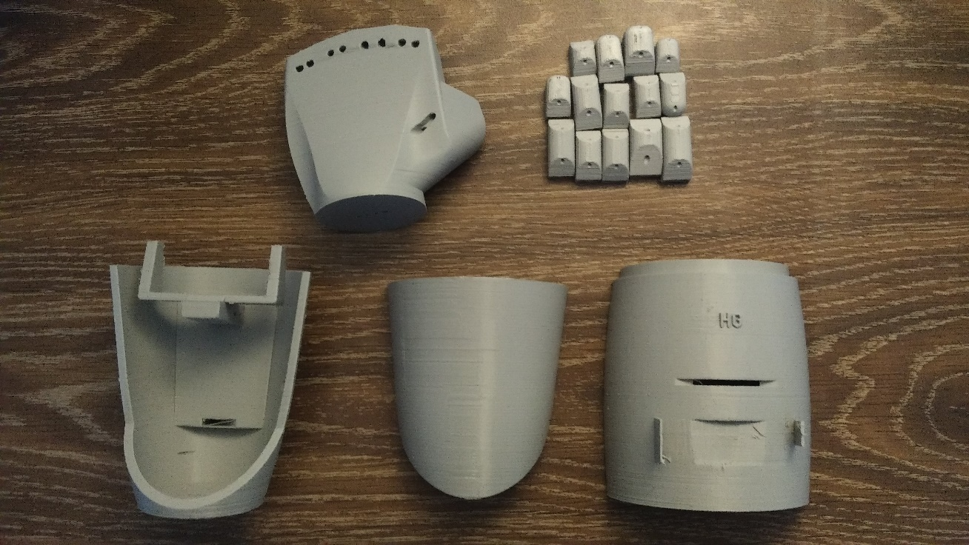

**Figure 1. Complete 3D Printout of Prosthetic**

### 3.1.1 Arduino Nano Board

Arduino itself is an open-source easy to use prototyping platform for individual interested in creating an interactive environment. It is a microcontroller that was created from the Arduino programming language and development environment. The Arduino Nano utilized in this project is a surface mount microcontroller based of the ATMEGA328 8-bit AVR RISC-based microchip that utilizes a 32KB ISP flash memory simultaneously with read/write capabilities. As the device only required 7-12volts for 5 Volts of operation at its pins, along with its miniscule body, is capable of being hooked up to 3.7V 600mah battery boosted up to supply 7V for portability whilst controlling the prosthetics servo motors and EMG sensor.

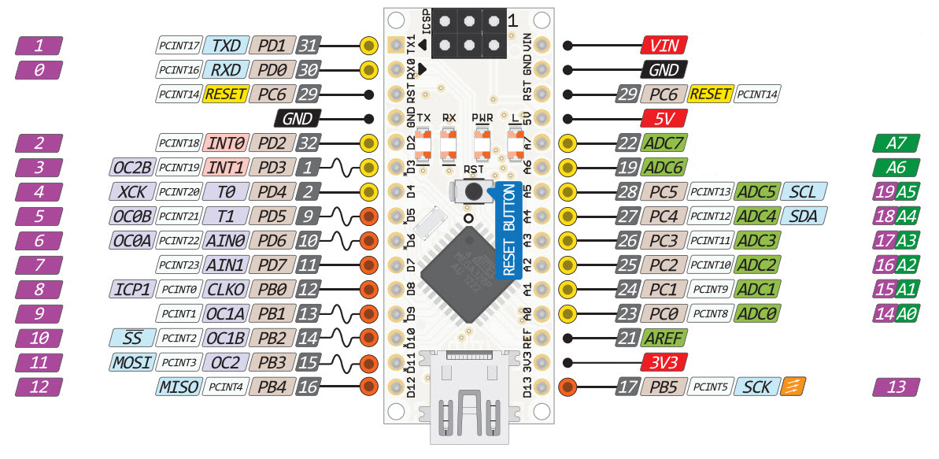

**Figure 2. Nano Board Pin Layout (Arduino AG, 2017)**

### 3.1.2 Servo Motor

Servo motors are electrical devices, or specifically a rotary actuator, that rotates a machine with precision. Internally, servos require a DC motor connected to a sensory feedback closed-loop system that has a servo drive for positioning. The servo drive provide control and optimized torque to dictate the rotation of the motor. Its optimization occurs with the use of gears that converts the high speed of the motor into higher torque. Due to its being a closed loop system it provides for a higher performing device compared to standard stepper and AC induction motors.

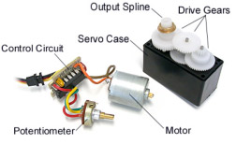

**Figure 3. Inside a Servo Motor (Eglowstein, H., n.d.)**

For this project a standard high powered positional servo motor was used. The Tower Pro MG995 metal gear servo allows for 120 degree rotation at an operating voltage of 4.8 to 7V and stall torque of 8.5kgf ·cm to 10kgf ·cm. It operates using a Pulse Width Modulation (PWM) cycle of 50Hz and is readily available in the Arduino Integrated Development Environment (IDE) library for coding purposes.

### 3.1.3 MyoWare EMG Sensor

The MyoWare EMG sensor is a surface mount device that us electromyography to evaluate the motor actions potential energy activity at a muscular region. MyoWare senses the electrical activity that propagates through the nerves neuromuscular junction and measures its electrical potential. MyoWares’ surface mount sensor is gaining popularity as it is a non-invasive technique that measures muscle activity making it strategically imperative for biomedical engineering purposes that connect human muscles to the environment. The sensor conversion occurs by analyzing the raw voltage signals from the muscle connection and converts it into a smooth positive waveform outputting integer values through rectification of the EMG signals.

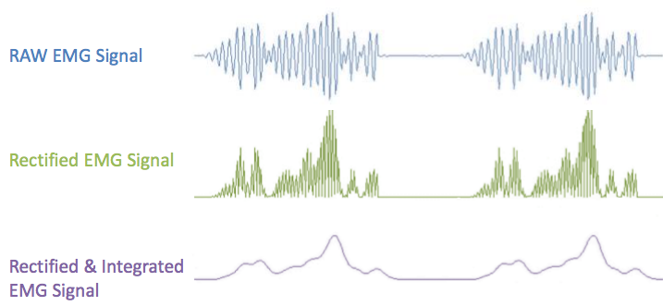

**Figure 4. MyoWare Process of Conversion (Mayo Clinic, 2017)**

This sensor is then utilized in conjunction with the Arduino Nano microcontroller to interface the sensor with a physical device. As such the primary output is the amplified and rectified integrated signal that will work with the Arduinos analogue to digital (ADC) converter.

To use Advancer Technologies MyoWare Sensor requires certain steps. First to use the Rectified EMG Signal instead of the raw signal requires connecting header pins to the plus (+), sig and minus (–) holes located on the edge of the sensor. The positive terminal is considered ‘hot’ and is connected to the 5V output header of the Arduino Nano. The negative terminal is then connected to the Arduinos ground. Lastly the sensors sig header is connected to pin A3.

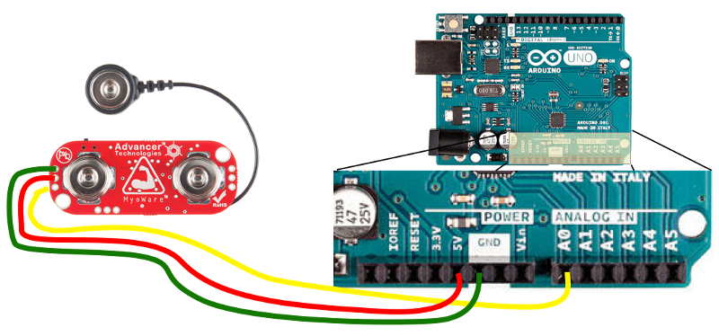

**Figure 5. MyoWare Microcontroller Setup (Mayo Clinic, 2017)**

Next a sketch is created in the Arduino IDE. Arduino development software contains two main loops within a sketch. The void setup(){} function runs when the Arduino is powered on. The void loop(){} function is a simple loop that repeats a process every millisecond. The outbound pin is then assigned a variable names. One servo rotates to contract the thumb and the other is used to contract the four remaining fingers, therefore the pins were assigned as thumb and fingers in the sketch. MyoWares output data can give voltage threshold reading of 0-1023, therefore the voltagethreshold variable is set to a value that will trigger an action. These variables are defined before the main loops.

In void loop(){} will set the starting points when the Arduino is turned on. Here, syntax .attach is used to create the servo object at a pin. Serial.begin(9600) is used so that the Arduino can start listening to the data from the sensor. 9600 refers to the baud rate of Arduino per second.

Finally in the void loop(){} function of the sketch, an if statement is used to say that if the currrentvoltage driven from the MyoWare sensor is greater than the predefined voltagethreshold the servo motors listed by their variables names thumb and finger will rotate 120 degrees. If the currentvoltage value is not met, then no action will be seen by the prosthetic. The code for the project is attached in Appendix C bellow.

Lastly, the sensors placement was to be determined. Correct position is very important as it greatly effects the strength of the signal. The EMG electrode must be placed on the center of the muscle body aligning with the muscle fibers. The correct placement will record a midline of the muscle belly that is between the innervation zone and myotendon junction. Misplacement of the sensor will result in a weaker signal due to the reduction in the number of motor units measurable and interface due to crosstalk. Therefore first determining the muscle group is needed. For this project the bicep was chosen. The electrodes are then snapped into place on the sensors connections and placed in the middle of the muscle body. The second electrode will line in the direction of the muscles length. Lastly, the reference electrode is placed on a nonadjacent muscle close to the target.

For the best result adjusting the gain of the muscle sensor is possible. The gain potentiometer is located on the lower left corner of the sensor. Adjusting it counterclockwise will increase the output gain and vice versa. Increasing the gain beyond a certain point will saturate the Complementary metal-oxide-semiconductor (CMOS) amplifier therefore maintain a minimum output signal level is crucial.

### 3.1.4 Lithium-Ion Battery Management Circuit

Lithium-ion batteries utilize a profile charging designed to ensure longevity and safety. When the battery is discharged to a certain point a preconditioning charge of 10% is applied preventing the battery from overheating until it is capable of accepting constant current again. Batteries are then charged at a constant current of 0.5C until 4.1-4.2Volts is reached. When 4.2 Volts is reached the charger switches to constant voltage to remove any form of overcharging. As constant voltage is maintained the current reduces to 0.1C till which point charging is discontinued. Therefore to deter from overcharging and undercharging a charging module is required to control the final voltage to within 50mV of 4.2Volts to detect full charge of the battery.

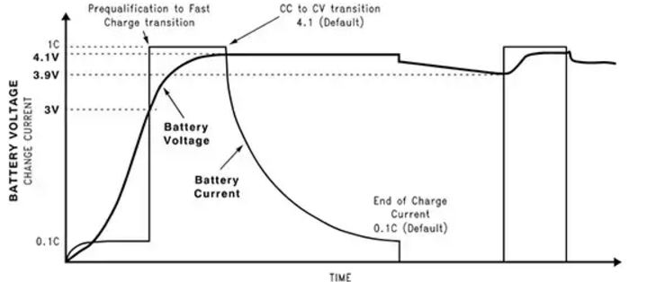

**Figure 6. Li-Ion Charging Profile (Battery University, 2016)**

For these reasons the TP4056 charging module was utilized to control the onboard 600mah 3.7 Volt battery of the prosthetic. The TP4056 is a constant current/voltage linear charger for a single cell Li-Ion battery ideally utilized for mobile applications. Internally it utilizes a P-channel metal-oxide-field-emitting transistor (PMOSFET) architecture requiring no blocking diode for negative charge current. The charging module also uses a thermal feedback regulator for the charge current in high temperature and power applications. The TP4056 provides a constant 4.2 volts charge voltage and will automatically stop the charge cycle when current flow drops by 1/10 the programmed value after float voltage has been reached. The Figure below shows the conventional application of the charge module for a lithium ion battery.

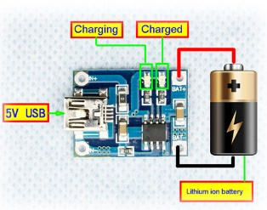

**Figure 7. TP4056 Charging Module Diagram**

As can be seen by the following graph, to input a power supply voltage (Vcc) to the charging module requires a minimum of 4 Volts at 1 amp in a complete charging cycle, therefore the input circuit to the module must supply 4 volts or greater for a constant charge in the battery. This will be seen further in the diode rectification circuit.

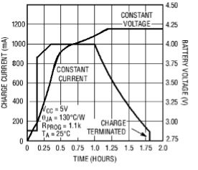

**Figure 8. Complete Charging Cycle of TP4056**

To utilize the TP4056 module in this project, the BAT+ and BAT- terminals are connected to the lithium ion battery. Then the output of the Full Wave Bridge rectifier circuit is connected the modules input IN+ and IN- terminals. It is noticed that the module will indicate that charging is occurring when the light emitting diode (LED) on the board will light up.

### 3.1.5 Boost Board

The output of the battery ounce it is charged is around 3.7-4.2 volts. The problem here is that the Arduino requires a constant supply of 7-12 volts in order to properly function. Therefore the voltage of the battery needs to be stepped up, or boosted to the required input voltage of the Arduino. This requires a boost converter. A boost converter is a DC-DC power converter that simultaneously steps up the voltage and steps down the current and is classified as a switch mode power supply (SMPS). In its simplest form a boost converter contains two semiconductors and an energy storing element with a filter to remove ripple voltage and supply constant DC voltage. Therefore to boost the voltage of the battery to the Arduino, the XL6009 power module was utilized.

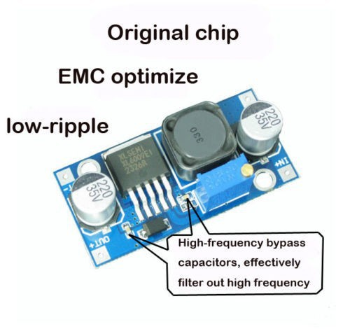

**Figure 9. XL6009 DC-DC Boost Converter**

This DC-DC step up SWMP uses the XL6009 main control chip to boost the incoming supply. It utilizes an LED display to show the actual output of the module and a Schottky diode allowing for a forward voltage drop with acceptably quick switching at a maximum efficiency of 96%. It also has ventilation holes to allow for better heat dissipation. Also the built in N-channel power MOSFET, fixed frequency oscillation and current-mode architecture type allows for a stable operation over supply voltage from 3.5Volts to 32Volts. Its application in the prosthetic is pretty simple. The positive and negative terminals of the battery are connected to the modules input GND and IN+ terminals. Then the modules output GND and Out+ terminals are connected to the input of the Arduino Nano microcontroller. Using a screwdriver to vary the potentiometer allows the boost converter to set the desired output voltage. For this application it was set to 7 Volts to account for minimal power losses whilst boosting.

### 3.1.5 Assembly

Firstly, all the 3D prints were arranged in sequence to form the shape of the prosthetic. Next, fishing wire was braided through each hole to connect the fingers. The fingers were then tied to the palm piece and singed in place. The fishing wire was then threaded through the palm piece. A glue gun was then used to connect the hand piece to the arm pieces. The servo motors were then placed accordingly. Setting the servos to 0 degrees then threading the fishing wire through them. The wire was tied in place so that the fingers would move as the servos rotated. The servos were then locked into place with screws. After placing the cover piece in place the mechanical prosthetic was plasti-dipped to rubber coat for protection. Initially, the servos and EMG sensor were connected to the Arduino with a secondary supply on a breadboard for testing. The EMG was placed on the bicep and tested with the Arduino code as seen in Appendix B. As the tests were satisfying, the electrical components were then soldered on to a perforated circuit board and placed within the prosthetic.

### 3.2 Induction Coupling Build Process

There were two parts required for the build of the wireless charger, a transmitter and receiver circuit. For the transmitter circuit an H-Bridge Inverter is required to convert the DC supply into an AC voltage. This AC voltage must transfer through a coil and be received by the Full Wave Bridge Rectifier Circuit to convert the AC voltage back into DC for constant supply to the TP4056 battery charging module. The process of the build of these circuits is shown below.

### 3.2.1 H-Bridge Inverter Circuit

What is required from this circuit is to invert the DC power supply into an alternating supply for wireless power transfer at a very high frequency for efficiency. This requires the use of an H-Bridge circuit. An H-Bridge is a circuit that contains a four switching elements with a load in the center. The diagram represents an H symbol, deriving its name. The switching elements are either bi-polar or FET transistors, and in high voltage applications, IGBT.

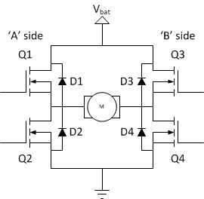

**Figure 10. H-Bridge Configuration (Modular Circuits, n.d.)**

Operationally, the H-bridge is quite simple. When Q1 and Q4, labelled in the diagram above, are turned on Switch 1 will activate causing a forward electron flow through the load. When Q2 and Q4 are turned on, Switch 2 will activate and the load will have a negative electron flow. Q1 and Q2, or Q3 and Q4, must never turn on at the same time as that will cause a low resistance path between power and ground, short circuiting the power supply. Therefore the switching of the H-bridge inverter is dependent on the following truth table.

**Table 2. H-Bridge Inverter Truth Table (Modular Circuits, n.d.)**

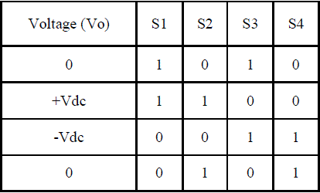

An H-bridge inverter, also known as a Single Phase Full Bridge inverter, for an inductive load, will generate a square wave voltage output waveform with its peak dependent on the inductance, switching frequency and input voltage.

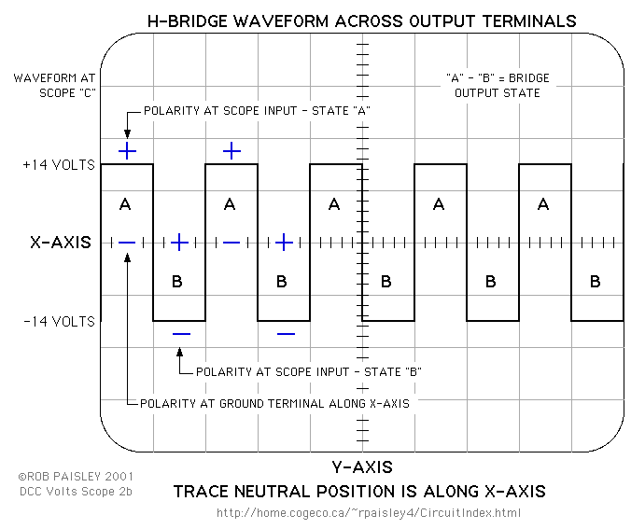

**Figure 11. H-Bridge Ideal Square Wave Output (Harish et. al., n.d.)**

In the diagram above, the square wave represents the voltage shown across the output terminals of the bridge. The square wave represents the fact that the output is therefore twice the voltage of the power supply. Noticeably, the instantaneous output voltage will never be greater than the H-bridge supply voltage as the output of the bridge is equal to the input minus the drop across the diodes. The output of the inverter will basically contain a chopped AC voltage with zero DC component as it contains harmonics. To reduce the high frequency harmonics, an LC section low pass filter is used at the output. The Fourier analysis of the harmonics and instantaneous output voltage is seen in Appendix D. The filtered outputting waveform can be classified as the switching between on and off states of a given input voltage. This is what creates the inverted AC voltage of DC supply.

To create the H-Bridge inverter for a high frequency power application to an inductive load, IRFZ44N MOSFETs, IR2113 MOSFET Driver ICs, NE555N timer IC and a 74HC4049N inverting IC were utilized.

### 3.2.1.1 IRLZ44N MOSFET

Metal-oxide-sulphate-field-emitting-transistors are a type of field emitting transistor (FET) that have an insulated gate which determines the conductivity of a device. The IRLZ44N power MOSFET utilizes an advanced processing technique for a low on-resistance per silicon area. This along with its capability for fast switching speeds making it extremely reliable to use. With a power dissipation level of 50 Watts and low thermal resistance, it is utilized in the H-Bridge for switching with an input voltage of 12VAC, providing 24Vpp at its output with minimal internal losses. These MOSFETs are then controlled by two IR2113 MOSFET Driver ICs in a bootstrap configuration.

### 3.2.1.2 IR2113 MOSFET Driver ICs

The IR2113 is a high voltage and speed power MOSFET and IGBT driver with independent high and low side reference output channels. The output of this devices features a high pulse current buffer stage made for minimizing driver cross-conduction. Also, to simply its use in high frequency applications, propagation delays are made to match. The bootstrap configuration, where part of the output of an amplified stage is then applied back to the input, increasing the impedance of the amplifier, which pulls the operating point of the IRLZ44N transistor above the power supply rail.

### 3.2.1.3 NE555N Timer IC

The 555 timer is an integrated circuit that is used for timer, pulse generation and oscillator applications. The standard 555 timer IC is created using 25 transistors, 2 diodes and 15 resistors on a silicon chip in an 8 pin package. The timer operates in 3 different modes; bistable, monostable and astable. In the bistable operation, the 555 timer operates as a flip-flop. In monostable it operates as a ‘one shot’ pulse generator. Finally, in the astable state, the 555 timer operates as an oscillator. The NE555N timer IC in the inverter circuit application is utilized in its astable operation to generate a pulse width modulation. The PWM generated is a continuous stream of rectangular pulses at a specified frequency.

### 3.2.1.4 74HC4049N inverting IC

The 74HC4049N inverting integrated circuit is a HEX inverting high to low level shifter. The high speed Si-gate CMOS driver provides six inverting buffers with a modified input protection structure. This allows for input voltages of up to 15Volts to be used. This function allows the inverting buffers to be used as a logic level translator, converting high to low level logic whilst operating at a low voltage supply.

### 3.2.1.5 H-Bridge Inverter Assembly Process

To increase the current through the transmitter coil, the H-bridge was assembled with the use of MOSFETs in order to apply an alternating voltage to the load. This, simultaneously creates an alternating current because of its oscillatory properties. In this application, four IRLZ44N MOSFETs are controlled by two IR2113 MOSFET driver ICs in a bootstrap configuration. Then the control signals for the drivers are generated by the NE555N timer IC and 74HC4049N inverter IC. Firstly, the 555 timer created a PWM signal at 150 kHz, adjustable with the potentiometer, with a 50% duty cycle. The PWM signal is then connected to the high in pin of the first IR2113 Driver IC and the low in pin of the second IR2113 Driver IC. This allows for the diagonal MOSFETs to turn on and off. Then, the 74HC4049N inverting IC will invert this signal and then drive it to the low in pin of the first IR2113 driver and the high in pin of the second IR2113 driver to control the other two MOSFETs. This then creates the outputting AC voltage and sinusoidal current necessary to be applied to the transmitting coil for wireless power transmission.

### 3.2.2 Litz Coils

Litz wire culminates of multiple strands of insulated copper wire due to the skin effect. The skin effects says that high frequency magnetic fields penetrate a conductor up to a certain depth. This means that most of the current through the coil will travel through the outer layer instead of the inner part which inevitably increases the conductors’ resistance. This resistance is important due to the loss factor. The loss factor is the relationship between the power loss and output power, which needs to be as low as possible. It decreases with an increasing K and Q value. K is defined as the positioning of the transmitting and receiving coils in relation to one another, which is relatively low due to air coupling. This requires a greater Q value in compensation. Q is determined as the quality factor of the coil. Formulaically, this is defined as the relationship between the inductive reactance and the coils internal resistance. Therefore to improve the coil quality, requires an improvement in the inductive reactance of the coil. The inductive reactance is as follows.

|  |  |  |
| --- | --- | --- |
|  | $$XL=2πfl$$ | (18) |
|  |  |  |

Thus, to increase the inductive reactance either requires an increase in the operational frequency or increase in inductance. There are two ways to do this; increasing the number of windings of the coil, which will also increase the internal resistance, or using a ferrite plate. The ferrite core will simultaneously improve the magnetic fields between both coils and remove any unnecessary emission. Therefore, the WE760308100110 transmitter coil was utilized.

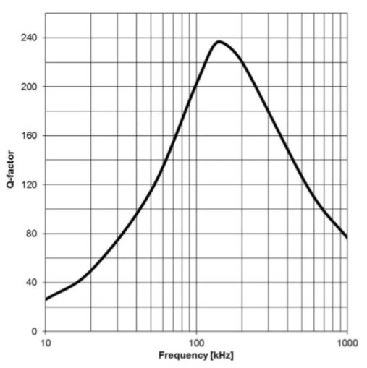

**Figure 12. Coil Quality vs. Frequency Graph**

As determined by the datasheet of the coil, the above graph shows that the coil quality reaches a maximum value of 240 at a frequency of 150 KHz. With a maximum inductance of 24µH, the required capacitance at 150 KHz resonance frequency can be determined. As equal power transmission from the transmitter to the receiver is required, a capacitor at both equally inductive coils is soldered; one in series with the transmitter coil and the other in parallel. The supply lines of the transmitter coil are then connected to the H-Bridge inverter circuit and to the Full Wave Bridge rectifier circuit for the receiver.

### 3.2.3 Full Wave Bridge Rectifier Circuit

After wireless power transfer has occurred through the transmitter and receiver coils, the AC voltage must be converted back in DC to supply power to the charging module. Rectification theory states that rectification by rectifying both halves of the AC cycle must occur for maximum power output. This will minimize power losses that occur when regulating the voltage down to 5Vdc. Therefore a full wave bridge rectification circuit is required. The following schematic was utilized to visualize a working rectifier circuit.

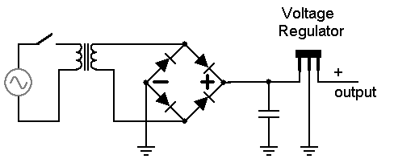

**Figure 13. Full Wave Bridge Rectification Circuit (Agarwal, T., n.d.)**

A full wave bridge rectifier will utilize both halves of the AC cycle to convert AC to DC. The arrangement of the circuit consists of four diodes in a bridge configuration which will provide the same output polarity for either input polarity. When the positive half cycle of the incoming signal is propagating through two parallel diodes will be forward biased, and the other two parallel diodes will be reversed biased, or turned off. The opposite will happen in the negative cycle of the incoming waveform. This makes no difference to the load as the current through the load is unidirectional. The output of the bridge rectifier will be the below shown pulsating DC signal.

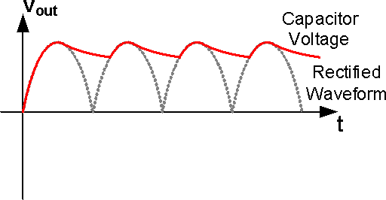

**Figure 14. Pulsating DC Signal of Diode Bridge Circuit (Agarwal, T., n.d.)**

At this point the frequency will double its input value. Across the diode power loss will occur at around 0.5-0.7Volts. As the voltage is the output across two diodes, the power loss will be from 1-1.4Volts. After the signal has propagated through the diode bridge, it will pass through a parallel capacitor creating a steady state DC signal. The parameters of the capacitor are based of the working voltage, which is required to be higher than the no-load output value and the capacitance value, determined by the amount of ripple created by the DC voltage. Finally, the outputted unregulated DC signal from the capacitor will be stepped down to a working 5Vdc with the voltage regulator. The L7805CV linear voltage regulator was used in this project to power the charging module that requires 4-12Vdc in order to function.

## Chapter 4: Tests Results and Analysis

### 4.1 Results Layout

The following results are presented in 4 sections:

* Strength Analysis of the Mechanical Prosthetic
* Transmitter and Receiver calculations and results
* H-Bridge Inverter Simulation and Results
* Full Wave Bridge Rectifier calculations and results

To determine if a working neuroprosthetic hand functionalized with wireless power transmission is possible, this section will contain all the simulations and results of each individual part, that combined, form this project. Some parts of this project contain theoretical simulations and physical simulations, others consists of calculations and analysis. It is assumed that the theoretical and physical application of each part will culminate to create the neuroprosthetic hand. Certain results may lead to inaccuracies due to negligence when testing or do to unverified calculations, such as assuming ideal scenarios that could lead to inefficiencies. They will still be included so that the reader may form a conclusion on the project.

### 4.1.1 Mechanical Prosthetic Simulation

For the 3D printed mechanical part of the prosthetic, testing and simulations were done in two parts. First being theoretical, formed by using simulation software. The second being practical, through physical testing the prosthetic to see what it could handle.

### 4.1.1.1 Strength Simulation

The fingers of the prosthetic will mimic the results of a simulation of the finger extension mechanics to contact forces. This is done as the fingers are positioned from flexed, to fully extended. This can be applied to find the fingers joint bone-to-bone contact forces and extrinsic and intrinsic muscle forces. The muscleotendonal structure of the human finger is extremely complicated. As seen by its posterior (dorsal) view, the bone has three segments; the insertion on extensor tendon to base of distal phalanx, the slip of long extensor tendon to lateral bands and the extensor expansion (hood) connected to the metacarpal bone. These three segments are similarly 3D printed into joint pieces that are connected to form a finger. The biological finger effectively functions through contraction within the muscle allowing finger motion through forces that are excreted by the joint capsules, ligaments and joint articular surfaces. This is mimicked by the internal servo motors of the prosthetic connected to the fingers for rotation.

Ideally, the investigation into biomechanics would include investigations into the biomechanical input of the tendon network on isometric movements with force analysis conducted using finger models. The forces of a realistic simulation of the human finger are shown below.

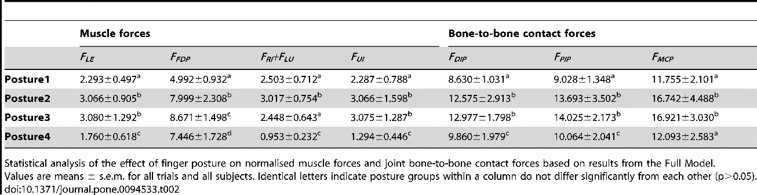

**Figure 15. Statistical Analysis of Forces on a Biological Finger (Hu et. al., 2014)**

This statistical analysis shows the different bone-to-bone contact force and the muscle forces at various angles of rotations, or postures. It is seen that the results of the biomechanical tests show that there is an advantage provided by the tendon/muscle network. Though this may have its limitations, as the tendon network is represented by lines in the experiment (Hu et al., 2014), when in reality the finger is an assembly of multi-directional fibers with viscoelastic properties, it is comparable to the analysis of rotation and forces to the prosthetic limb. This analysis was attempted through the Abacus software but failed as the STL file was not capable of converting to a file type that would work with the software. Also the files were too complex for simulations to take place. Finally, the parameters required for conducting the simulation were not known to the full extent.

### 4.1.2.1 EMG Sensor Threshold Verification in Arduino IDE

As the MyoWare sensor was placed on the biceps brachii or forearms flexor digitorum superficialis and profundus for testing, *Serial Monitor* in the Arduino IDE was activated in *Tools* to read the incoming voltage as physical contraction of the bicep occurred. These voltage readings would range from 0 to 1023. It was determined that at a value of 439, contraction was recognized, therefore a potential energy was generated as shown below by figure 16. It was determined that the system will be able to monitor the EMGs data, print the incoming data and analyze it to direct an action with the Arduinos programming logic.



**Figure 16. Serial Data from the MyoWare Sensor**

### 4.1.2.2 EMG Sensor Physical Simulation

After the positive and signal terminals of the MyoWare sensor are connected to the bicep barchi, with the negative connected to a laterally distant portion of the bicep as reference, the sensor and Arduino begin serial communication telling the Arduino to read the threshold value of the sensor and transmitting that data to the servos. It is seen that minor flection of the muscle will excite the servo to rotate, allowing contraction to take place in the prosthetics fingers, which is an ideal scenario for amputees that require a neuroprosthetic hand. For a more precise reading, the potentiometer was adjust for sensitivity.

### 4.1.2.3 Prosthetic Physical Simulation

Physically, the prosthetic only has two positions, full extension or full flexion. These means the prosthetic is currently only capable of a few tasks, such holding, grasping and hand shaking. A physical simulation was conducted with all three tasks to varying degree. It was seen that as an object sat on a perpendicular plane, the prosthetic was able to hold it and then let go, accomplishing the grasp task. Next, the prosthetic was able to pick up and hold small objects, like an empty water bottle for a certain amount of time, accomplishing the hold task. Heavier items failed as the tension in the fingers was not strong enough to do so. Also, the versatility of the 3D print deteriorated with time do to use. This could be because of the type of print, the tension of the internal wire and strength of the servo motor. Finally, to test the shake function the prosthetic contracted with a palmer supination grasp to another biological hand, successfully shaking it. This means that overall, the neuroprosthetic was a success as it is capable of providing function to its user through an EMG connected at the muscle neuron.

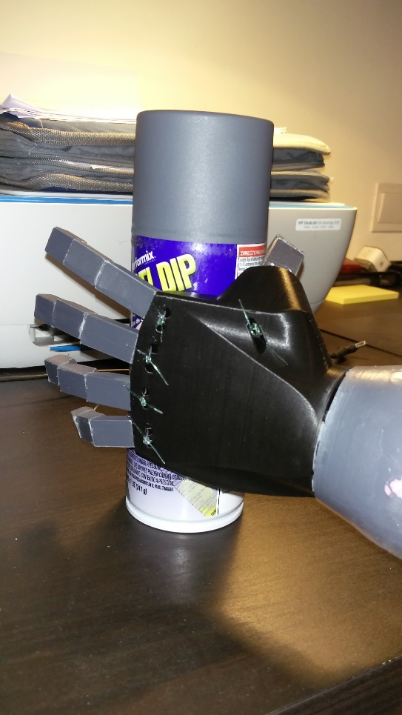

**Figure 17. Neuroprosthetic Mimicking Hand Function**

### 4.1.2 Transmitter and Receiver Coil Calculations and Results

To realize a physical transmitter and receiver it was determined that a litz wire pancake coil is to be made. This means that the transmitter and receiver will function at a frequency determined by the coil quality factor, Q. To determine the coil quality factor requires knowing the inductance of the coil, working resonance frequency and internal coil resistance.

To determine a specific inductance of the coil for wireless power transmission requires the following characteristics of the wire:

Length of litz wire = 1.5 meters

Number of turns = N = 10 turns

Area of Inner Core = $πr^{2}= π{0.03}^{2}=2.827 x {10}^{-3}$

Therefore the Inductance of the coil is calculated using equation 7.

$$Inductance= \frac{µ_{0}N^{2}A}{l}$$

$$= \frac{\left(4πx{10}^{-7}\right)\left({10}^{2}\right)\left(2.827 x {10}^{-6}\right)}{1.5}$$

$$=2.36 x {10}^{-7}=23.6 x {10}^{-6}=23.6µH$$

After the inductance is calculated and the working fundamental frequency is determined, the coil quality may be determined using equation 11.

$$Coil Quality=Q= \frac{XL}{R}$$

Where, $XL=2πfl$

Inductive reactance is thus calculated as follows with equation 18.

$$XL=2π(150x{10}^{3})(23.6μH)$$

$$=22.24$$

The capacitance value required can be calculated using equation 10.

$$F= \frac{1}{2π\sqrt{LC}}$$

$$C= \frac{1}{4π^{2}f^{2}L}$$

$$= \frac{1}{4π^{2}{\left(150x{10}^{3}\right)}^{2}\left(23.6μH\right)}$$

$$=42.32nF$$

As the peak to peak voltage applied to the coil is 24V, (1.5 x 24) = 36V is the rated voltage of the capacitor required.

The internal resistance of the wire coil is determined by the following equation.

|  |  |  |
| --- | --- | --- |
|  | $$Ω= \frac{ρl}{A}$$ | (19) |

Where, $ρ$ is the resistivity of the material, $l$ is the length of the wire and A is the cross-sectional area.

When dealing with a coil wounded by litz wire, the internal AC resistance of the wires is determined by its relationship between the resistance to AC and DC. This is shown by the following formula in equation 20 (New England Wire Technologies n.d.).

$$\frac{Resistance to Alternating Current}{Resistance to Direct Current}=H+K*{\left(\frac{N*D_{1}}{D_{0}}\right)}^{2}*G$$

|  |  |  |
| --- | --- | --- |
|  |  | (20) |

Where, H is the resistance ratio of the individual strands of the litz wire when isolated, G is the Eddy-current Basic Factor = ${(\frac{D_{1}*\sqrt{F}}{10.44})}^{4}$, F is the operational frequency, N is the number of strands of the cable, $D_{1}$ is the diameter of the individual strands over the copper in inches, $D_{0}$ is the diameter of the finished cable over the strands and K a constant dependent on the number of turns, N.

To determine the DC resistance of the conductor requires knowing the following parameters; the amp-watt gauge of the individual copper strands, number of strands in the cable and the factors that lead to the increased length of the individual strands per unit length. Using this, the following formula may be applied in equation 21.

|  |  |  |
| --- | --- | --- |
|  | $$R_{DC}= \frac{R_{s}*{\left(1.02\right)}^{N_{B}}*{(1.03)}^{N_{C}}}{N_{s}}$$ | (21) |

Where, $R_{s}$ is the maximum DC resistance of the individual strands, $N_{B}$ is the number of bunching operations, $N_{C}$ is the number of cabling operations and $N_{s}$ is the number of individual strands.

The construction of the litz wire coil then consisted of 500 strands of 40 AWG single-film polyurethane-coated wire at an operational frequency of 150 KHz constructed with two bunching operations and one cabling operation.

The DC is resistance is then calculated as follows.

$$R_{DC}= \frac{1152.3*{\left(1.02\right)}^{2}*{(1.03)}^{1}}{500}$$

$$=2.47\frac{ohms}{1000 feet}$$

Thus, the AC to DC ratio is calculated as follows.

$$\frac{Resistance to Alternating Current}{Resistance to Direct Current}=1000+2*{\left(\frac{500*0.0031}{0.94}\right)}^{2}*\left(7.8 x {10}^{-5}\right)$$

$$=1.0424$$

$$R_{AC}=1.0424 x 2.47=2.57\frac{ohms}{1000 feet}$$

Finally the coil quality, Q, is determined as follows.

$$Q= \frac{XL}{R}= \frac{22.24}{2.57}=8.65$$

With the information calculated, it was concluded that a factory wounded litz coil be utilized as it will give a higher coil quality factor, because of the increased inductance due to the ferrite plate, in relation to the high frequency utilized for efficient wireless power transfer.

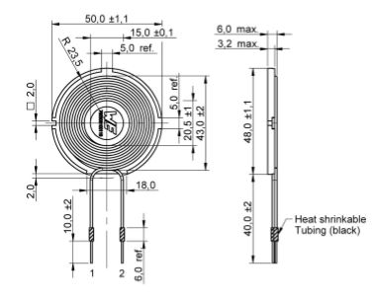

**Figure 18. Litz Wire Pancake Coil Specification**

### 4.1.3 H-Bridge Inverter Simulation

To determine whether the H-Bridge inverter would function in this application a MATLAB simulation was produced. Here, an input DC voltage of 12 Volts is applied to a load, the RL transmitter coil, at a frequency of 150 KHz. As switching occurs through the MOSFETs of the inverter, a square wave output is formed. The MOSFET are energized in pairs allowing DC current flow, bi-directionally flowing through the inductive load. This switching between states is derived from the control of the pulse width output of the 555 time IC. The NE555N timer IC practically produces a pulse width modulation waveform with a duty cycle of 50% and variable frequency when tested separately on the breadboard as shown by the oscilloscope graph below.

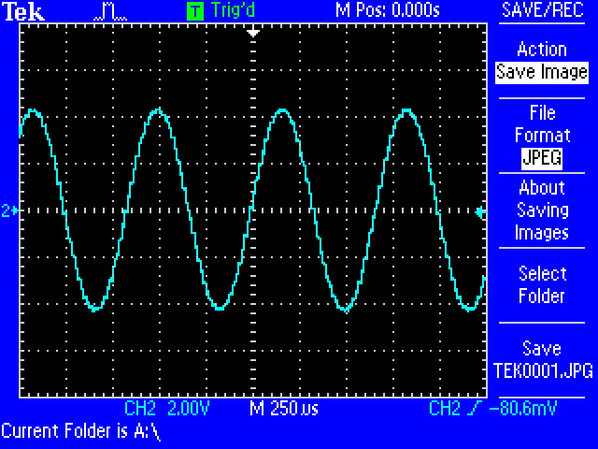

**Figure 19. 555 Timer PWM Output**

As the relay between inputs and the inverter output remains open, the PWM will send four drive outputs to the gate drivers. The gate drivers are then accepting low-power inputs from the controller, producing the high current gate to the power MOSFETs. The gate drivers are what allow the switching frequency to occur so rapidly. MOSFET driver ICs are used to maximize the switching speed by driving current to the gate so the MSOFET spends the least amount of time possible at the transmitter state.

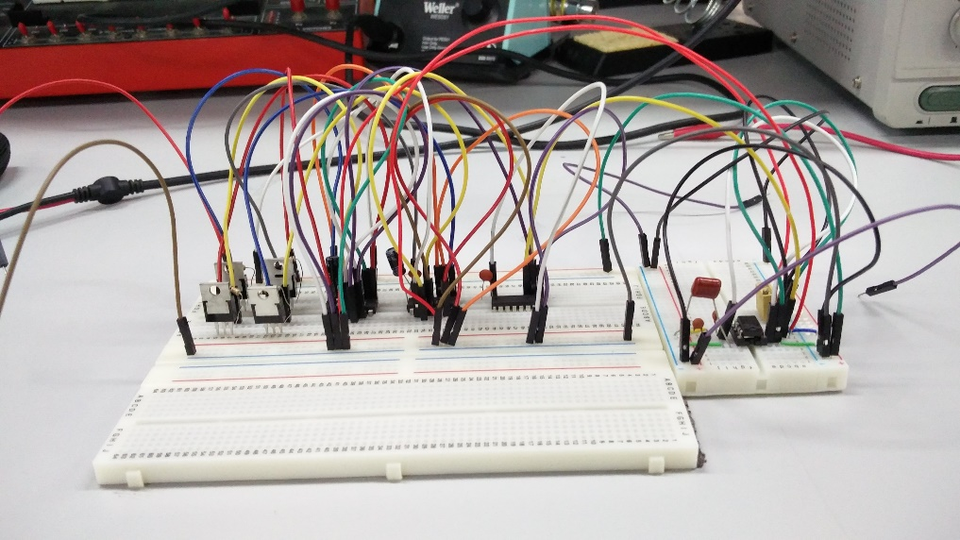

**Figure 20. Breadboard Testing of H-Bridge Inverter**

Appendix D contains the schematic and MATLAB simulation for the H-Bridge Inverter Circuit above.

It is observed that at the 12Vdc input the switching of the H-bridge creates on and off states. The outputted waveform produces a 24V peak to peak voltage as shown by figure 18 below. This does not include any power losses through the transistors, assuming an ideal scenario. The MATLAB simulation also produces an alternating current for charging and discharging in the outputted waveform. An alternating waveform is defined as one that varies in both magnitude and direction making it a ‘bi-directional’ waveform. The term AC refers to a time-varying waveform or a sinusoidal waveform. The shape that is observed is drawn by plotting the instantaneous ordinate values of either voltage or current against time. The AC waveform is therefore completely changing its polarity every half cycle, alternating a positive maximum value and a negative maximum value respectively with time. This periodic waveform is generated using a fundamental frequencies and superimposing it with harmonics of varying frequencies and amplitudes. A square voltage waveform displays the same fundamental as any other periodic wave, the difference being that instead of gradual fluctuation, it is more indicative; switching between on and off states. Since there is an alternation, there must be a frequency oscillation, therefore an AC sinusoidal current for the generated square voltage, may also be seen in Figure 21.

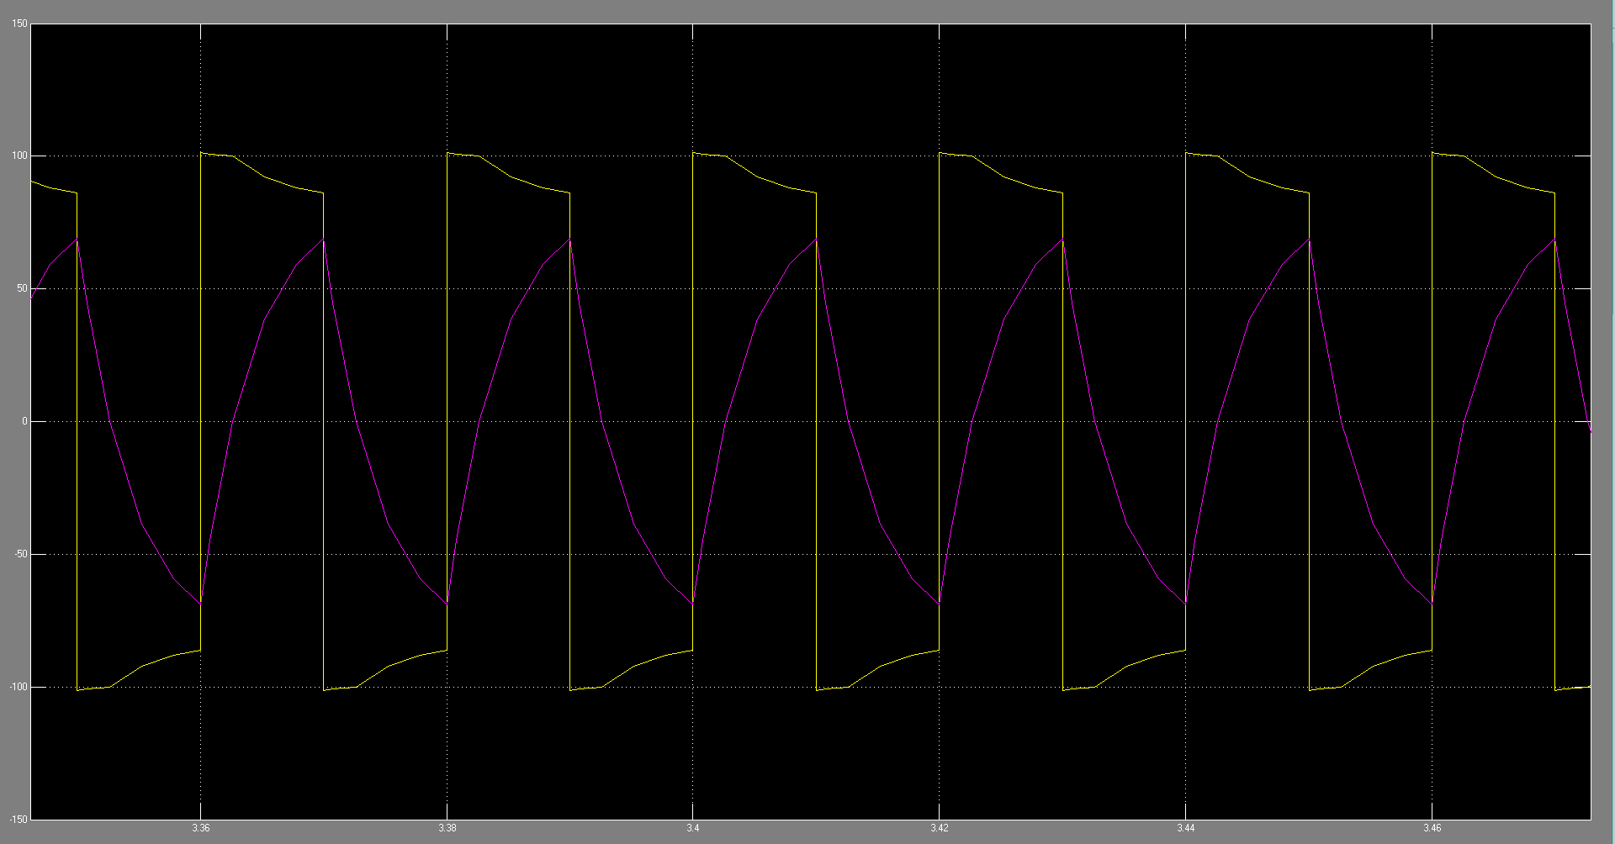

**Figure 21. H-Bridge Output Waveform**

### 4.1.4 Full Wave Bridge Rectifier Results

To realize a rectification circuit that would efficiently receive an input of 24Vpp, assuming no power losses, and step down the rectified voltage to 5Vdc for charging the battery, a fully wave bridge rectifier had to be made. This entailed the following calculations.

First, the RMS value of the input must be calculated with the following derivation. Formulae is taken from Appendix C.

$$V\left(t\right)= V_{m}\sin{ωt}$$

|  |  |  |
| --- | --- | --- |
|  | $$V_{m}=\frac{V_{pp}}{2}$$ $$= \frac{24}{2}=12$$ | (22) |

The RMS value is then calculated as follows in equation 24.

|  |  |  |
| --- | --- | --- |
|  | $$V_{rms}= \frac{V_{m}}{\sqrt{2}}$$ $$= \frac{12}{\sqrt{2}}=8.48V$$ | (23) |

Then, the DC output Voltage is calculated as follows in equation 24.

|  |  |  |
| --- | --- | --- |
|  | $$V_{DC}=\frac{2V_{m}}{π}$$ $$= \frac{2\left(12\right)}{π}=7.64V$$ | (24) |

Next, assuming ideal diodes, the Rectification Efficiency ( $η\%)$ is calculated.

|  |  |  |
| --- | --- | --- |
|  | $$η= \frac{P_{out}}{P_{in}}= \frac{{I_{ac}}^{2}R}{{I_{rms}}^{2}R}$$ $$= \frac{\frac{{V_{dc}}^{2}}{R}}{\frac{{V_{rms}}^{2}}{R}}$$ $$=\frac{{V_{dc}}^{2}}{{V_{rms}}^{2}}$$ $$η\%= \frac{{V_{dc}}^{2}}{{V_{rms}}^{2}} x 100$$ $$= \frac{7.64}{8.48} x 100=90.01\%$$ | (25) |

It is seen that the efficiency of a full wave rectification circuit is capable of up to 90.01% efficiency considering no losses.

Next, to determine the type of diodes utilized in this circuit requires finding out the peak inverse voltage (PIV), or what is also known as the reverse breakdown voltage of the circuit. Since the input voltage, $V_{m}=12Volts$ the peak inverse voltage has to be greater than this value.

$$PIV≥ V_{m}$$

$$PIV ≥12Volts$$

Finally, the output frequency was calculated. Since the sinusoidal signal, when passed through the diode bridge creates a pulsating DC signal, it is assumed that the time period, T, is cut in half, as shown in the following graph (figure 16). Therefore, the following output frequency was determined.

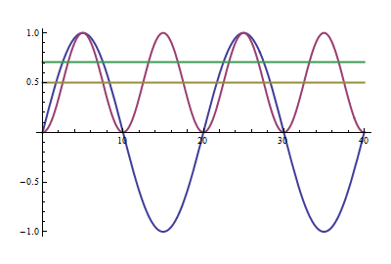

**Figure 22. Diode Bridge Frequency Comparison**

|  |  |  |
| --- | --- | --- |
|  | $$f= \frac{1}{T} →T= \frac{1}{f}$$ $$T^{'}= \frac{1}{2}T$$ $$T=2T^{'}$$ $$\frac{1}{F_{in}}=2 x \frac{1}{F_{o}}$$ $$F_{o}=2 F_{in}$$ $$=2\left(150KHz\right)=300KHz$$ | (26) |

Where T is the sinusoidal time period, T’ is the pulsating DC time period and $F_{o}$ is the output frequency.

It is determined the output frequency of the full wave bridge rectification circuit is thus twice the input frequency, thus in this application it will be 300 KHz.

## Chapter 5: Conclusion

### 5.1 Final Project Results

The final results for this project are a working induction coupling wireless power transfer system for an electromyographic neuroprosthetic of the hand. It is seen that this design when functioning as intended for the user, will provide adequate hand mimicking and simplified battery charging for a prolonged prosthetic life.

The electromyographic was capable of reading minute potential energy values that expended from the muscle neuron, therefore making it a very capable tool in the field of neuroprosthetic. This along with a 3D printed mechanical design proved that a low power one fit all modular neuroprosthetic of the hand was possible.

It is seen that with an H-Bridge design, a lower power input will facilitate adequate AC power for wireless power transmission. The coils, with a quality factor of 240 at a working frequency of 150 KHz will see minimum losses as transmission occurs. The full wave bridge rectifier should be able to receive the incoming AC power and convert it back into DC to successfully supply power to the charger module, with minimum ripple voltage. This meant that the design should suffice for a prototype of a 3D printed neuroprosthetic hand that requires this additional functionality for its users.

### 5.2 Project Limitations and Problems

There are many working factors involved in successfully manufacturing a neural prosthetic. Initially, determining the mechanical design, how it’s going to be made, when and for what cost, were the problems that needed investigation. It was determined that the safest, simplest and most cost effective option was using 3D printing and an online, open source schematic to base the prosthetic design on. 3D printing has its own problems, specifically where to print, which printers to use, and the types of filaments available for printing. To minimize costs the printing of the prosthetic was taken care of in Karachi, Pakistan. The type of filament utilized was PLA as it was the cheapest printing option for the best available printing quality. Problems after printing still occurred. Two of the STL files were incorrectly printed, either by mechanical or human error. Either it was printed at an undesirable temperature or the support used while printing was removed too hastily, causing damaged to the printed pieces. Negotiations with the printing company followed by their immediate cooperation and reprint of the prosthetic pieces took place. Next sourcing the materials required to assemble the 3D printed took away valuable time. These materials includes the shipment of the electromyographic sensor, the Arduino Nano board, lithium ion battery, high torque servo motors, fishing wire, rubber sheets, DC/DC boost converter board, inductive wire, diode rectifiers, capacitor, MOSFETs and a voltage switching regulator. With further investigation it was determined that a charging module was also required to supply constant voltage and current to the battery. Once all the parts are tracked down, ordered and received, depending on shipping costs and delivery estimates, assembly was able took place.

After the mechanical prosthetic has completed its design coding and testing is the next chronological step. Arduino has a specific layout when it comes to coding a project with their controllers. There are two steps to any coding algorithm in the Arduino IDE software. The coding includes a setup function and a loop function. The way the code works is, is that for the electromyographic sensor, a threshold value will be determined. These threshold values correspond to a muscular twitch or movement. Once these values are assessed they are written into the code so that for a specific value a specific move or function is generated by the prosthetic. The limitations to this is that once a set number of functions will be displayed by the prosthetic. Errors may also occur in reading threshold values, therefore undesirable movement may occur. A solution to this was rigorous testing and precision when determining these threshold values.

The next step is determining how to build the receiver and transmitter circuits for the wireless power transmission of the neuroprosthetic. An initial problem that occurred was the quality of the self-wound coil for the transmission and receiving circuits. It was seen that without a ferrite plate, the inductance of the coil was too low for the coils internal resistance, therefore sourcing the coil was required as it would provide a better quality factor and therefore a more efficient wireless power transfer system.

The final piece to build was the transmitting circuit. Here many problems occurred. Firstly, making the connections whilst using the schematic was tedious and time consuming as there were many to make. If one wire was incorrectly placed in the circuit, the square waveform required would not be produced on the oscilloscope. Additionally, a square wave is not the most efficient form of DC to AC conversion. This would require a modified sine waveform output, which was not implemented. To simplify the circuit a Dual H-Bridge module can be used to drive the gate ICs with the same 555 timer signal controller to produce the same outcome. Considering a simplified design will also bring simplicity to the user and minimize their risks.

### 5.3 Future Work of the Project

The future of this project entails further utilizing more advanced designs to the overall project. It would be an advantage to test other printing materials that would allow for a sturdier, stronger build to test if the prosthetic would be able to hold heavier objects. Additionally, testing different wiring materials and motors that will increase the tensile strength of the prosthetic should be conducted. Also, studying other methods for neural commination besides electromyography should be done. Finally, choosing a design that would allow for additional motors would increase functionality by allowing for independent movement of each finger, giving the user additional functions is possible. Also, considering other viable power transmission techniques, such as RFID should be tested. Finally, considering other types of Neuroprosthetics to build is an option, externally and internally, such as cochlear implants for the ear, heart monitors and prosthetic legs.

### 5.4 Project Uses

The point of this project is to provide a proof of concept to establish a safer, faster, more convenient prosthetic to those affected by amputation. This concept is adding functionality to a prosthetic to do two things. Firstly, utilize an electromyographic sensor to enable an amputee to use the prosthetic with relative ease. This sensor will create a neural pathway that allows an amputee to think of an action and reproduce that with a prosthetic. The second function is wireless power transmission. Wireless power transmission is added to the prosthetic by using induction coupling techniques. This increases the functionality of the prosthetic as it allows the amputee to easily charge it for use whenever needed whilst minimize unnecessary contact with the point of amputation, reducing the risk of infection. The information gathered here will further help the development of lower cost higher performing prosthetics that have greater functionality for its users. Therefore this project identifies how to utilize EMG sensors and induction coupling functionally with a prosthetic hand for those affected by amputation while also allowing engineers to design, develop, implement and fundamentally understand the technology.

## Chapter 6: Sources of Information

### 6.1 References

Akhtar et. al. (2016), ‘A Low-Cost, Open-Source, Compliant Hand for Enabling Sensorimotor Control for People with Transradial Amputations’, *University of Illinois at Urbana-Champaign* [online], 1-3.

Basic Electronics Tutorials (2017) *Electromagnetic Induction and Faradays Law* [online].

Casanova, M. (2013), ‘Canonical circuits of the cerebral cortex as enablers of Neuroprosthetics’, *Frontiers in Systems Neuroscience* [online], 7(77), November, 1-3.

Eapen, B., Murphy, D. and Cifu, D. (2017), ‘Neuroprosthetics in amputee and brain injury rehabilitation’, *Experimental Neurology* [online], 287, 8 August, 479-485.

Georgakopoulos, S. and Jonah, O. (2011), ‘Optimized Wireless Power Transfer to RFID Sensors via Magnetic Resonance’, *Florida International University* [online], 1421-1424.

Grahn et. al. (2014), ‘Restoration of motor function following spinal cord injury via optimal control of intraspinal microstimulation: toward a next generation closed-loop neural prosthetic’, *Frontiers in Neuroscience* [online], 8(296), 17 September, 1-12.

Gross, R. (2016) *Robotic Prosthetic Hand by grossrc* [online].

GreatScott. (2016), *IR2113 H-Bridge* [online].

Johns, B. (2012), ‘Designing a Qi-compliant receiver coil for wireless power systems, Part 1’, *Texas Instrument* [online], 8-14.

Jun et. al. (2015), ‘Wireless thin film transistor based on micro magnetic induction coupling antenna’, *Scientific Report* [online], 5(18621), 1-9.

Kwok, R. (2013), ‘Neuroprosthetics: Once more, with feeling’, *Nature* [online], 497(7448), 176-178.

Smith, G. and Chetter, I. (2015), ‘Infection in prosthetic material’, *Surgery (Oxford)* [online], 33(11), 559-564.

‘The Qi Wireless Power Transfer System Power Class 0 Specification’ (2017) *Wireless Power Consortium* [online], 291-294.

Yu et. al. (2010), ‘A Reconfigurable Hebbian Eigenfilter for Neurophysiological Spike Train Analysis’, *International Conference on Field Programmable Logic and Applications* [online], 556-561.

Hu et. al. (2014), ‘Biomechanical Analysis of the Human Finger Extensor Mechanism during Isometric Pressing’, *PLOS* [online].

iMotions (2015) *What is EMG (Electromyography) and how does it Work?* [online].

The Physics Classroom (2016) *Electrical Potential* [online].

Battery University (2016) *How do Lithium Batteries Work?* [online].

Battery University (2010) *Is Lithium-ion the Ideal Battery* [online].

Brain, M. (2017), ‘How Lithium-ion Batteries Work’, *How Stuff Works* [online].

Basic Electronic Tutorials (2017) *Mutual-Inductance* [online].

Basic Electronic Tutorials (2017) *Transformer-Basics* [online].

Hyper Physics (2012) *Electricity and Magnetism* [online].

Basic Electronic Tutorials (2017) *Diode* [online].

Basic Electronic Tutorials (2017) *AC Inductors* [online].

Agarwal, T. (n.d.) *Full Wave Rectifier Circuit with Working Theory* [online].

Eglowstein, H. (n.d.) *Introduction to Servo Motors* [online].

Arduino AG (2017) *Arduino Nano* [online].

Mayo Clinic (2017) *Electromyography (EMG)* [online].

### 6.2 Bibliographies

ProtoParadigm LLC (2013) *The Difference between ABS and PLA for 3D printing* [online].

Gravitech (2014) *Arduino Nano 3.0 (Atmega328)* [online].

Microchip Technology Inc. (2017) *ATmega328* [online].

Reed, F. (n.d.) *How Do Servos Work* [online].

Marzloff, G. (2016) *Using MyoWare: A Low Cost Surface Electromyographic Sensor for Developing Rehabilitation Devices (Tutorial)* [online].

Digi-Key Electronics (2016) *A Designers Guide to Lithium (Li-ion) Battery Charging* [online].

Modular Circuits (n.d) *H-Bridge – The Basics* [online].

Harish et. al. (n.d.) ‘Power Quality Improvement for DC-AC Converter by Using Cascading H-Bridge Multilevel Inverter’, *International Journal of Advanced Research in Electrical, Electronics and Instrumentation Engineering* [online].

Cogeco Inc. (2012) *DCC Current and Voltage Measurement and Waveforms and Voltages for DCC Systems* [online].

Rollins, M. (n.d.) *Power* [online].

New England Wire Technologies (n.d.) *Litz Wire Theory* [online].

Analog Devices Inc. (2013) *Chapter 7: Diode Application Topics* [online].

Power Circuits (2015) *Fourier Series of Full-Wave Rectifier Circuit* [online].

All About Circuits (n.d.) *More on the ‘Skin Effect’* [online].

## Appendix A: Minute of Meetings





















## Appendix B: Project Timetable



## Appendix C: Fourier Transform of Full Wave Bridge Rectifier

Typically, there is a single component of the Fourier series is desired in the case of full wave rectification. This allows for the computation of the signals fundamental frequency, wanted components and RMS values.

To determine this, the Fourier series of the full wave rectification signal, $\left|V_{0}\cos{{(ω}_{in}t)}\right|$ is computed. This wave has a period of $T= \frac{π}{ω_{in}}$.

Taking advantage of the symmetry of integrals,

$$T= \frac{-T}{2}$$

With the angular frequency taken as,

$$ω= \frac{2π}{T}=2ω_{in}$$

The Fourier coefficients are then defined as,

$$a_{0}= \frac{ω_{in}}{π} \int_{-\frac{π}{2ω_{in}}}^{\frac{π}{2ω_{in}}}{V_{0}\cos{{(ω}_{in}t)}dt}$$

$$=\frac{{2ω}_{in}}{π} \int_{0}^{\frac{π}{2ω_{in}}}{V_{0}\cos{{(ω}_{in}t)}dt}$$

$$= \frac{{2ω}_{in}}{π} {\left[\frac{V_{0}}{ω_{in}}\sin{{(ω}_{in}t)}\right]}_{0}^{\frac{π}{2ω_{in}}}$$

$$a_{0}= \frac{2V_{0}}{π}$$

$$a_{n}= \frac{ω_{in}}{π} \int_{-\frac{π}{2ω_{in}}}^{\frac{π}{2ω_{in}}}{V_{0}\cos{{(ω}_{in}t)\cos{(2ω_{in}tn)}}dt}$$

$$b_{n}= \frac{ω_{in}}{π} \int_{-\frac{π}{2ω_{in}}}^{\frac{π}{2ω_{in}}}{V_{0}\cos{{(ω}_{in}t)\cos{(2ω_{in}tn)}}dt}$$

The coefficients $a_{n}$ and $b_{n}$ benefit when $∅= ω_{in}t$,

$$a_{n}= \frac{4}{π} \int_{0}^{π/2}{V_{0}\cos{(∅)\cos{(2n∅)}}dt}$$

$$= \frac{4V_{0}\cos\left(nπ\right)}{π\left(1-4n^{2}\right)}$$

$$b_{n}= \frac{2}{π} \int_{-\frac{π}{2}}^{\frac{π}{2}}{V_{0}\cos\left(∅\right)\sin\left(2n∅\right)dt}$$

= 0 for all $n≥1$

Therefore the Fourier series of a full wave rectified cosine function can be written as follows.

$$f\left(t\right)= \frac{2V_{0}}{π}+ \frac{4V_{0}}{π} \sum_{n=1}^{∞}{\frac{\cos{(nπ)}}{1-4n^{2}}} \cos{(2ω_{in}tn)}$$

It is determined that the fundamental frequency is thus twice of the AC input. The required term is the DC component equal to the RMS value of $\frac{2V_{0}}{π}$. Also, it is seen that the amplitude decreases as the number of coefficients increases with the greatest unwanted term being when $n=1$. Therefore the output of the inverter, in its simplest form will be that of a square wave of a given frequency $ω_{0}$.

## Appendix D: Schematic, Simulation and Fourier analysis for H-Bridge Inverter Circuit

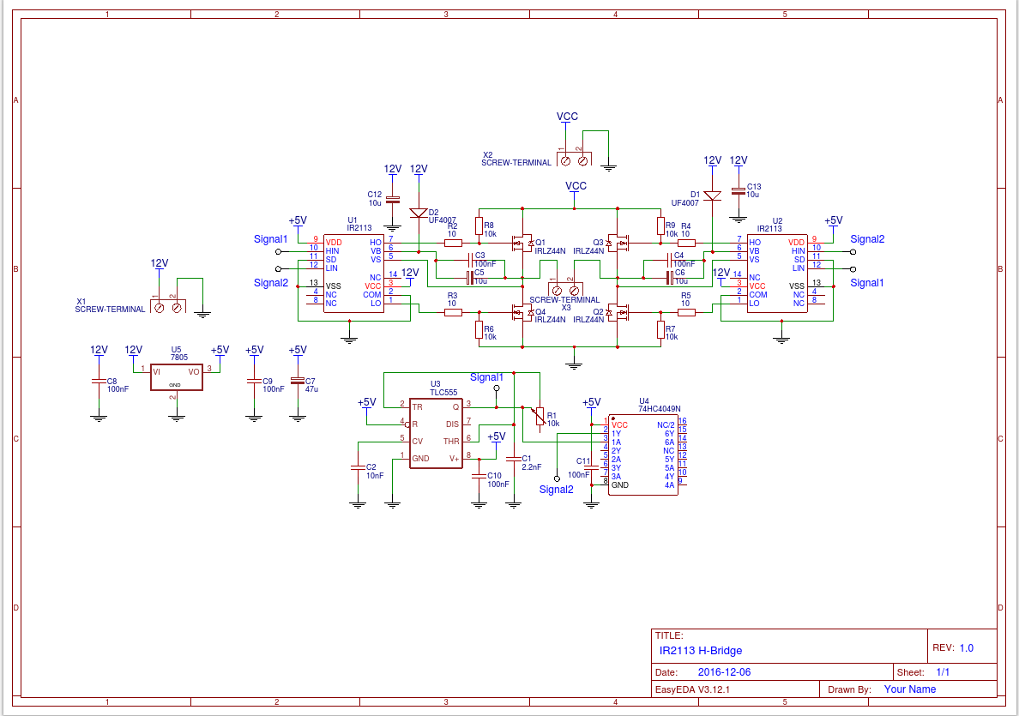

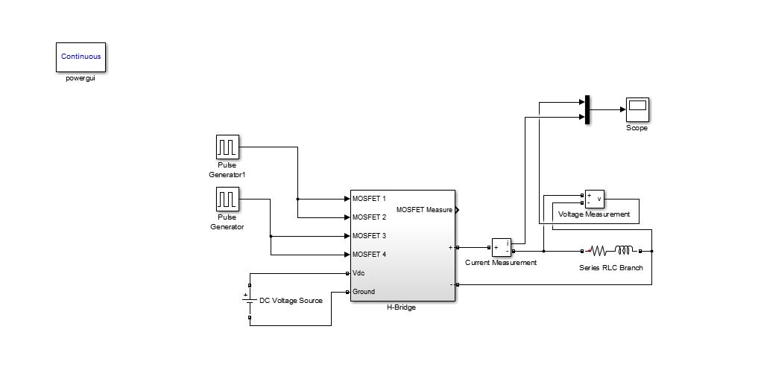

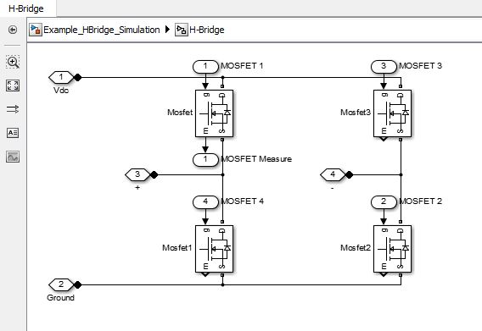

Fourier series for Harmonic Analysis:

$$a_{0}= \frac{1}{π} \int_{0}^{2π}{f\left(v\right)dθ}– DC term$$

$$a_{n}= \frac{1}{π} \int_{0}^{2π}{f\left(v\right)\cos\left(nθ\right)dθ– Cos term}$$

$$b_{n}= \frac{1}{π} \int_{0}^{2π}{f\left(v\right)\sin\left(nθ\right)dθ}– Sin term$$

Inverse Fourier Transform:

$$f\left(v\right)= \frac{1}{2}a_{0}+ \sum_{n=1}^{∞}{(a_{n}}\cos{nθ}+ b_{n}\sin{nθ)}$$

Where $θ=ωt$

$$a_{0}= \frac{1}{π} \left[\int_{0}^{π}{V_{dc}dθ+\int_{π}^{2π}{-V_{dc}dθ}}\right]= 0$$

$$a_{n}= \frac{V_{dc}}{π} \left[\int_{0}^{π}{\cos\left(nθ\right)dθ-\int_{π}^{2π}{\cos\left(nθ\right)dθ}}\right]= 0$$

$$b_{n}= \frac{V_{dc}}{π} \left[\int_{0}^{π}{\sin\left(nθ\right)dθ-\int_{π}^{2π}{\sin\left(nθ\right)dθ}}\right]= 0$$

This will give the harmonics of a square wave.

Fourier series for Instantaneous Output Voltage:

$$V_{0}= \frac{a_{0}}{2}+ \sum_{n=1}^{∞}{(a_{n}} \cos\left(nωt\right)+ b_{n}\sin\left(nωt\right))$$

When $a_{0}=0$ and $a_{n}=0$

$$b_{n}= \frac{1}{π} \left[\int_{-π}^{0}{\frac{-V_{s}}{2}sin\left(nωt\right)d\left(ωt\right)+\int_{0}^{π}{\frac{V_{s}}{2}sin\left(nωt\right)d\left(ωt\right)}}\right]$$

$$b_{n}= \frac{2V_{s}}{nπ}$$

As n = 1, 3, 5…

$$V_{0}= \sum_{n=1, 3, 5…}^{∞}{\frac{2V_{s}}{nπ}}\sin\left(nωt\right)$$

## Appendix E: Arduino IDE Code for Prosthetic

